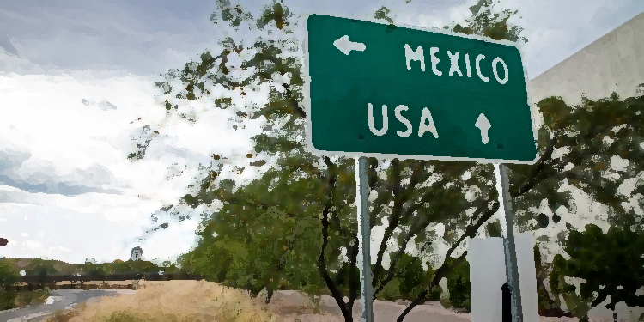
Want to know more about what is going at the U.S.-Mexico Border? Interested in learning more about immigration policy? Consider the PLSC Spring Break Trip to the U.S.-Mexico Border! Tuscon -Nogales-El Paso- Juarez
3 CREDITS INTERCULTURAL CREDIT COST Approx $1700

INFORMATION SESSION- Tuesday, Sept. 28 at 11:30 a.m. on the Steps of HP. Food will be provided.
Please RSVP at shorturl.at/syFS3 by Sept 24th if you are interested!

