STUDY ABROAD
ESTONIA

19 July - 7 August 2021
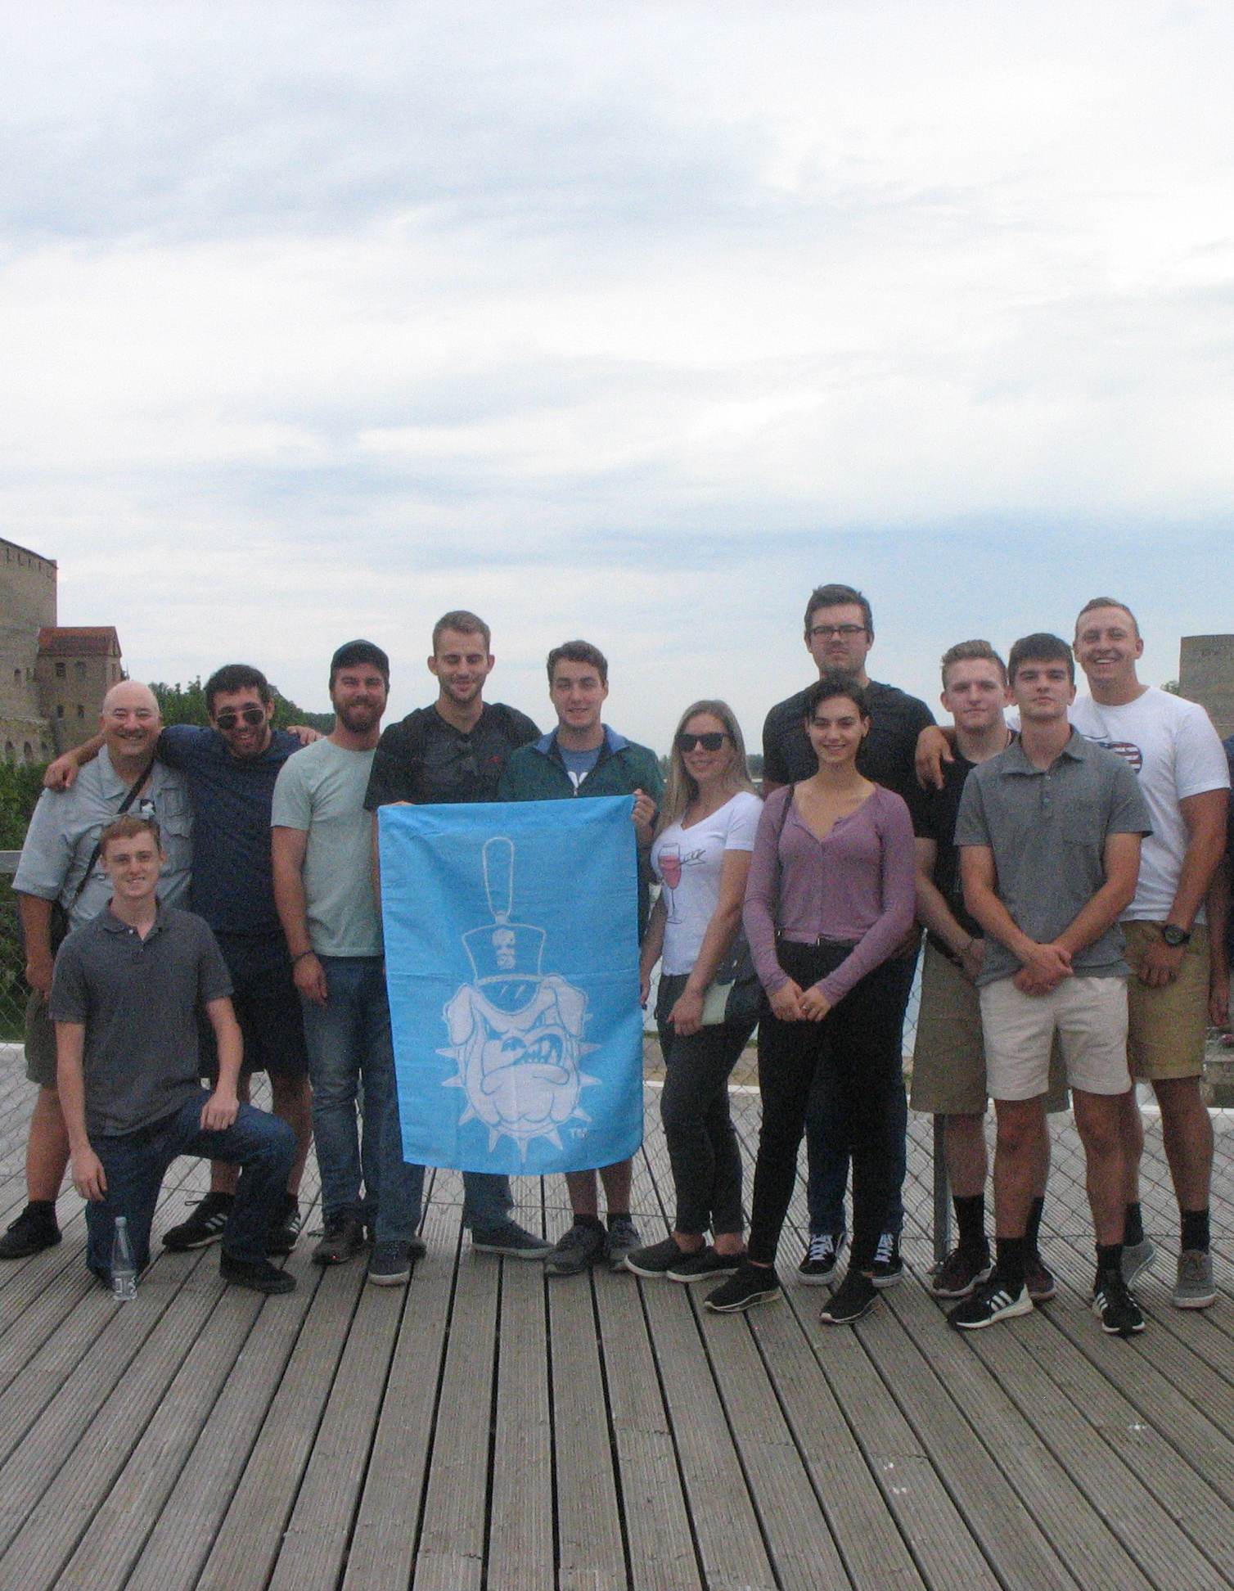

Standing on the Russian Border in 2019

A Joint Program of the Departments of Political Science and Intelligence and Security Studies open to Cadets, Day Students, Undergraduate Evening Students, and Graduate Students.

Given its strategic location on the northeast frontier of the European Union and NATO along the Russian border, it’s history as a former Soviet Republic, and it’s advanced cybersecurity programs (it is home to NATO’s Cybersecurity Defense Centre of Excellence) Estonia is among the most exciting countries of Europe for the study of international relations, military affairs, and cyber security. It’s natural beauty on the Baltic Sea presents Estonia an additional draw for study abroad this summer. Citadel students can enjoy a once-in-a-lifetime experience and adventure in Estonia this summer.

Why Study Abroad in Estonia this summer?

Two courses (6 total hours) of undergraduate credit (or graduate for MA students) that can be prefixed as PSCI and/or INTL depending upon your academic major and transcript needs. The courses are taught by Estonian professors. Each class is overseen by Dr. Terry Mays of The Citadel’s PSCI Department permitting both courses to appear as Citadel rather than transfer credit.

Our Two Courses:

- Estonia, Russia, and the International Relations of the Baltic Region

Choose one for enrollment

PSCI 433 91 Special Topics in International Politics (Estonia, Russia, and the International Relations of the Baltic Region)

INTL 465 91 Special Topics in Intelligence (Estonia, Russia, and the International Relations of the Baltic Region)

- Cyber Security and the Baltic Region

Choose one for enrollment
INTL 465 92 Special Topics in Intelligence (Cyber Security and the Baltic Region)

PSCI 433 92 Special Topics in International Politics (Cyber Security and the Baltic Region)

***Graduate Students should see Dr. Mays for options in both courses

DATES:

19 July: Arrival at Tallinn Airport in Estonia before 1pm for pickup and transfer to Tal Tech

20 July: Program Begins

7 August: Departure (Will be Tallinn or Helsinki, Finland. We are awaiting clarification on whether the Institute of International Affairs of Finland will host us for a day of briefings).

Students may arrive in Europe earlier than 19 July and/or remain in Europe later than 7 August but at their own expense and responsibility.

PROGRAM INCLUDES:

Tuition for the two academic courses, ground transportation in Estonia, Breakfasts and lunches (we found that students tend to want to eat suppers on their own off campus), housing (2 per room), planned excursions, a bus and tram pass for local travel, and travel medical insurance.

Excursions: 1 day and night in Narva on the Russian border. Visit to the local castle. Walk along the Russian border. Either a visit to a former Soviet prison location on a lake west of Tallinn or an outing to a firing range. Local political and cyber security offices depending upon which are open and receiving visitors during our three weeks. Visit to the military museum in Tallinn. Visit to the Finnish Institute of International Affairs if it is open for visitors. Tallinn walking tour.

PROGRAM DOES NOT INCLUDE:

Airfare (students can purchase discounted tickets on their own through student programs. Contact the Study Abroad Office for more information. Many students apply frequent flyer miles toward their tickets.)

Expenses in Europe before and after the official dates of the program.

Passport fees (If you do not have a valid passport...one that will not expire within 6 months after our travel dates...please begin the process immediately.)

Costs related to quarantine (housing and food) if the student must be in government mandated Covid-19 quarantine beyond the dates of the program due to testing positive for Covid-19. While not mandatory for the program, we highly recommend that each student be fully vaccinated for Covid-19 prior to departure. It is possible this could become an EU requirement prior to our departure.

COST: $3,490 per student (based on 15 students)

***POC: Dr. Terry Mays of The Citadel’s Political Science Department, mayst@citadel.edu

Trip Index for Payment to The Citadel Treasurer’s Office: 130132

Payments should be made to the above before Friday 21 May 2021

