PHIL 207/295: BUSINESS ETHICS AND SUSTAINABILITY IN THE BAHAMAS
May 5-19, 2021
(3 credits)

Faculty Leaders & Instructors:
Dr. Chris Tweedt, chris.tweedt@cnu.edu
Dr. Brandon Warmke, bdwarmke@gmail.com

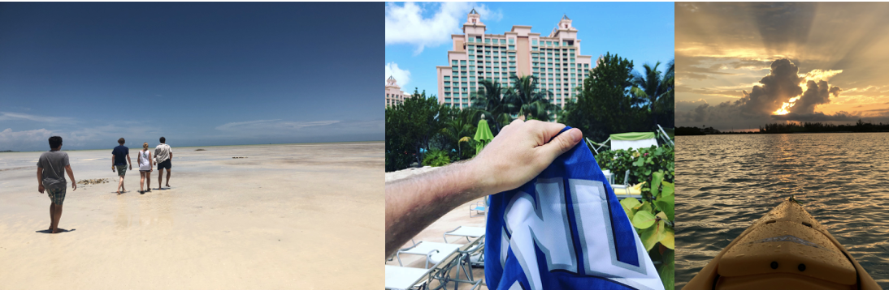

Prerequisites: There are no pre-requisites, and this course is open to all CNU students; however, students must apply, be accepted, and pay deposit fees in order to enroll.

Course Description:

This course focuses on applying critical thinking skills to ethical issues raised within a business setting, with a particular emphasis on issues related to sustainability. Critical thinking skills include analyzing arguments for validity, using both inductive and deductive arguments, increasing argument cogency, identifying common fallacies, analyzing statements for consistency, implications, contradictions; distinguishing fact from opinion; identifying inference and argument; addressing vagueness and ambiguity in language. Ethical issues include business and government initiatives, responses from affected populations, and the other-affecting decisions that each group makes.

This particular two-week course challenges students to think critically about business practices and internalize the effects of ethical and unethical actions by seeing firsthand the effects of these actions on the local environment, people, and businesses in the Bahamas. The Bahamas provides an excellent way to see the effects of decisions by the government, local businesses, and island residents and to examine the consequences of these decisions on governments, businesses, and people at varying population levels, from Nassau, the center of business and tourist activity, to Central Andros, an emerging but precipitously growing tourist destination, to South Andros, a recondite island with very little commercial activity. In each place, we will compare and contrast the business activities related to sustainability, the life of the island residents, and the environmental damage. To do this examination, we will have discussions with officials from the Bahamian Office of Sustainability and local business leaders and residents about the costs and benefits of commercialization and measures that the Bahamian government and local businesses are taking to ensure sustainability across the Bahamas.

Prior to the trip, students must complete six hours of classroom study, which prepare students to think in ethical frameworks before they take the trip, and they must pass the qualifying exam.

Application: bit.ly/CNUBahamas

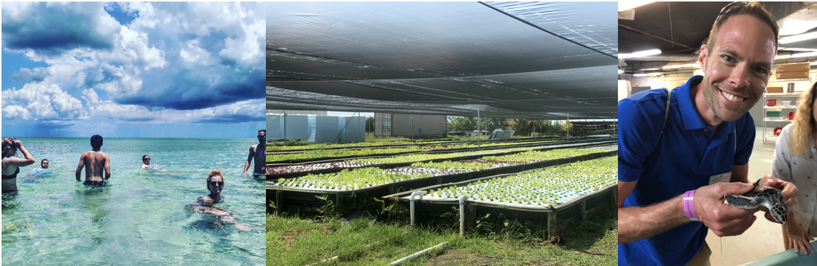

Program Fee: $4,900
This fee covers airfare, accommodations, ground transport, activity fees, international health insurance, and the majority of your meals.
This fee does not cover tuition. For tuition costs, see the Study Abroad Payment Form.

Learning Objectives
By the end of this course, students will be able to:
- Apply ethical thinking and reasoning: analyzing arguments, increasing argument cogency, identifying fallacies, analyzing statements for consistency, implications, and contradictions, and addressing vagueness and ambiguity in language
- Understand sustainability ethics, corporate social responsibility, and its impact on affected populations. The purpose of all of the activities on this trip is to help students internalize the concrete effects of ethical and unethical actions by seeing firsthand the effects on lives of people on those islands and the environment and to assess the morality of those actions as it pertains to the sustainability of people’s ways of life and the environment.
- Apply critical thinking skills not only in the classroom but in concrete and unfamiliar situations and business settings

Course Assignments:

Pre-Departure Meetings & Test: Students will be responsible for meeting for 6 hours prior to departure in order to become familiar with the fundamentals of ethics and sustainability, after which a 20-question test will be given. Students should be prepared to apply their understanding from the pre-departure meetings to concrete situations during the trip.

Class Preparation Summaries: Class Preparation Summaries: Each student will keep a notebook in which they answer questions each day to prepare them for the day’s activities. The questions students will be asked to answer will be given prior to the trip along with articles that students will need to read. The summaries will need to incorporate student understanding of the assigned reading and engaged reflection on the answers to the questions in order that students are prepared to 1) engage interviewees in informed ways and 2) interpret their experiences in a structured and evaluative manner. Students will also be asked to reflect on their experiences/interviews and to provide an analysis of the experience in light of what they learned when they responded to the questions posed for that day.

Participation and Discussion: The heart of this study abroad will be our direct encounters with the concrete living situations and environment of the Bahamas and our discussions with local officials. Accordingly, students will be expected to participate in all class activities and discussions. Points will be awarded for participating in these activities.

Course Final Paper: The research paper will be on a topic of the student’s choice in relation to the course themes. Faculty leaders must approve paper topics. Due June 30, 2021.

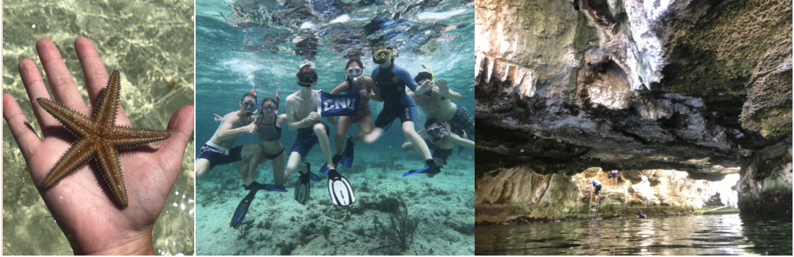

Grading Structure
Pre-departure Test: 25%
Class Preparation Summaries: 30%
Trip Participation & Discussion: 25%
Final Research Paper: 20%

Special Course Notes:
-This trip will include hiking up to 8 miles in one afternoon, underwater snorkeling in salt water, multi-hour outdoor activity, travel on small planes and in dirty taxis, and, in some cases, crowded housing. This trip will be fast-paced and packed with activity and experiences. Students are responsible for assessing their physical and social preparedness for this trip. Due to course activities including swimming, students must be able to use a snorkel and tread water or back float for at least 5 minutes.
-Please let the faculty advisors know if you have dietary preferences; not all preferences will be able to be accommodated; it may be difficult to find food to accommodate preferences.
-Rentals can be expensive; as a result, students will be responsible for bringing their own snorkeling gear (goggles with nose cover, snorkel, optional flippers) and appropriate clothing (e.g. sandals and swimsuit).
- All meals in Central Andros and South Andros will be covered by course fees, and breakfast in Nassau will be covered; airport meals and some meals in Nassau are not covered by course fees. Meals can be expensive in Nassau. Please bring cash accordingly.

Schedule

Please see the attached itinerary. Six hours of classroom instruction will precede the departing flight. Once all students have enrolled for the course, we will schedule that instruction to cohere with as many students’ schedules as possible.

Readings
Textbook: There is an assigned course packet that contains all the readings you will need to do beyond those listed below. Besides this course packet, there is no assigned textbook. (The cost of the course packet is not yet determined, but it will cost less than $75.)

Assigned Reading Pre-departure: (additional readings will be provided in the course packet.)
An outlook on business and life: What if money were no object?
Bahamas background: Fyre: The Greatest Party that Never Happened (Netflix Documentary)
Human Rights: Universal Declaration of Human Rights
Our responsibility to others: Peter Singer's ``Famine, Affluence, and Morality"
Treatment of employees: NYT's ``Inside Amazon", Business Insider's article about working in an iPhone factory
Background to Sustainability Issues: Hardin’s “Tragedy of the Commons”, An argument in favor of contemporary energy sources
Environmental Responsibility: Carnival’s dumping in the Bahamas, Deforestation, BBC's ``Chevron fined for Amazon pollution by Ecuador court'', Ecowatch's ``Fast fashion is the second dirtiest industry in the world'', Cobalt Child Slavery
Corporate Social Responsibility: Milton Friedman's ``The Social Responsibility of Business is to Increase its Profits", NYT's article on the famous Tylenol recall
Price gouging: An Interview with Martin Shkreli, Syprine, HEB, Zwolinski on Price Gouging, Forbes' “Price Gouging is bad politics but good economics”

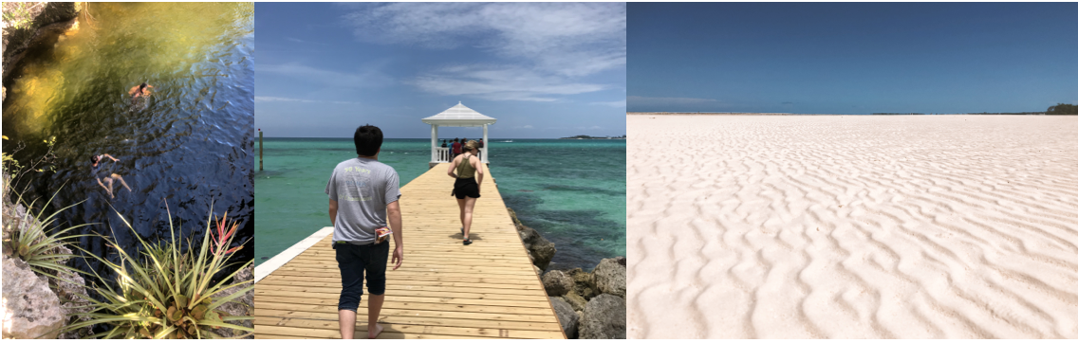

Honor Code: By being enrolled in this class, each student is expected to read, understand, and abide by the CNU’s honor code. CNU reserves the right to penalize any student whose academic conduct at any time is, in its judgment, detrimental to the University. This conduct includes plagiarism, collusion, cheating, giving or receiving or offering or soliciting information in examinations, or the use of previously prepared material in examinations or quizzes.
Class Policy on Cheating: You’ll receive an automatic F in the course if you share test questions or answers with other students, or if you quote another author without attribution. The purpose of these tests and written assignments is to test your knowledge. If use someone else’s answers or information, it undermines the testing process. I’ll report all seeming-plagiarism to CHECS and give you a 0 for the assignment. I won’t argue with you whether you did it intentionally. We all know how that will go. You’ll argue that you didn’t mean to do it, just like people who do it intentionally argue. So I’m not even going to ask. Please be intentional about not doing it.
Accommodations for Disabilities: In order for a student to receive an accommodation for a disability, that disability must be on record in the Office of Student Affairs, 3rd Floor, David Student Union (DSU). If you believe that you have a disability, please contact Dr. Kevin Hughes, Vice President of Student Affairs (594- 7160) to discuss your needs. Dr. Hughes will provide you with the necessary documentation to give to your professors. Students with documented disabilities are required to notify the instructor no later than the first day on which they require an accommodation (the first day of class is recommended), in private, if accommodation is needed. The instructor will provide students with disabilities with all reasonable accommodations, but students are not exempted from fulfilling the normal requirements of the course. Work completed before the student notifies the instructor of his/her disability may be counted toward the final grade at the sole discretion of the instructor.
Academic Success: The Center for Academic Success (located in Christopher Newport Hall, first floor, room 123) offers free tutoring assistance for Christopher Newport students in several academic areas. The staff in the center offers individual assistance and/or workshops on various study strategies to help you perform your best in your courses. The center also houses the Alice F. Randall Writing Center. Writing consultants can help you at any stage of the writing process, from invention, to development of ideas, to polishing a final draft. The Center is not a proofreading service, but consultants can help you to recognize and find grammar and punctuation errors in your work as well as provide assistance with global tasks. You may visit the Center for Academic Success to request a tutor, meet with a writing consultant, pick up a schedule of workshops, or make an appointment to talk one-on-one with a University Fellow for Student Success. If I become concerned about your course performance, attendance, engagement, or well-being, I will speak with you first. I also may submit a referral through our Captains Care Program. The referral will be received by the Center for Academic Success as well as other departments when appropriate (Counseling Services, Office of Student Engagement). If you are an athlete, the Athletic Academic Support Coordinator will be notified. Someone will contact you to help determine what will help you succeed. Please remember that this is a means for me to support you and help foster your success at Christopher Newport.

