When making a payment at www.curry.afford.com, choose “Curry College” in the drop down under Make a One-Time Payment

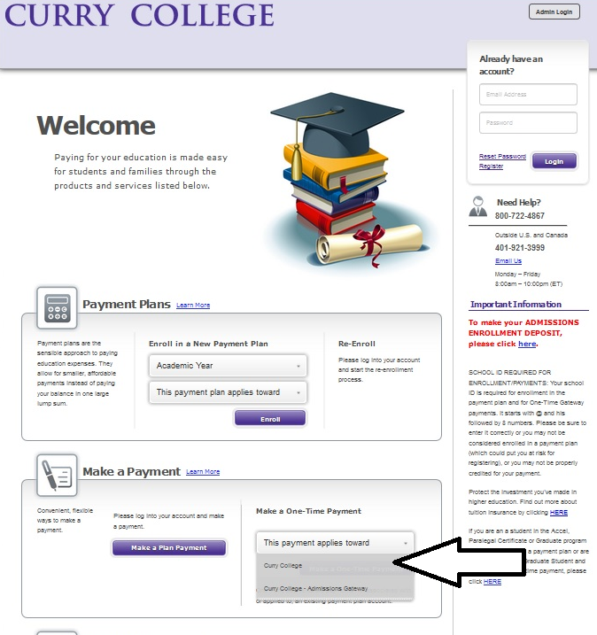

Hit “continue” when you get a pop up box. Then, complete the Student Information section. Choose term “Spring 2019” since your course is part of the Spring 2019 semester.
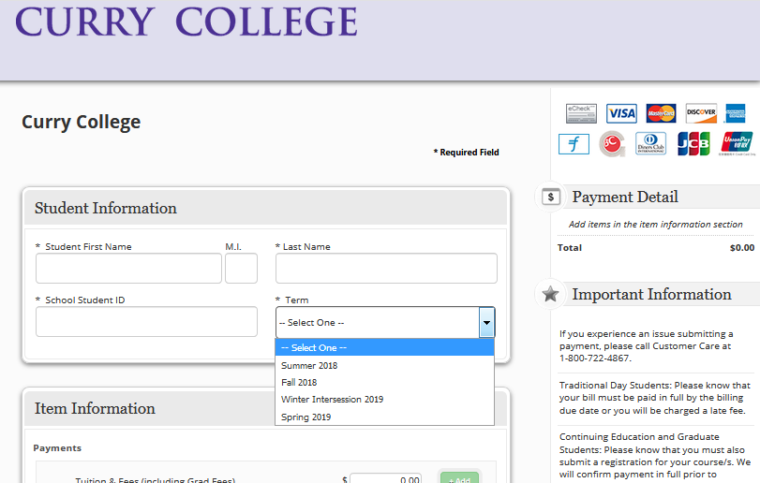

In the Item Information, enter the amount you’d like to pay in the “Trip” line, along with a description. The description should mention which trip the student is taking, and course name, if known. For example, “Italy trip – MGT3930 International Business”

