Study Aboard in Lithuania!
RSTD 370: Geoscience, Archaeology & Religion in Lithuania
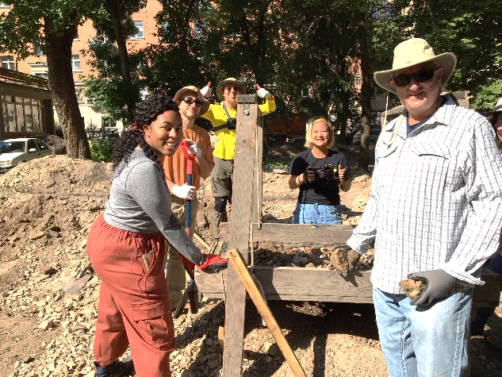
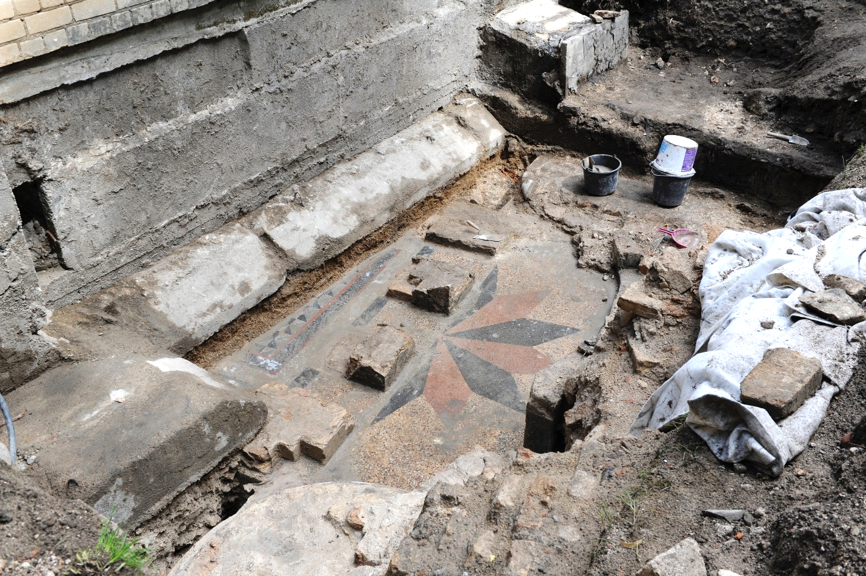

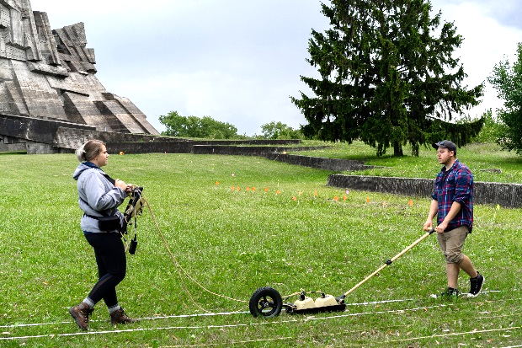

July 5-19, 2020
Learn how archaeology and geoscience are being used to map and uncover the lost institutions of Lithuania destroyed during World War II. This course focuses on the excavations of a five hundred year old synagogue buried underneath an elementary school in downtown Vilnius, Lithuania! Work with students from the University of Vilnius and students from around the world who are coming to excavate with us. Learn about the 700 year old Kingdom of Lithuania by visiting some of the sites of battles, churches. (yes, even Napoleon was there!) castles, museums, and cemeteries.
Learn how to use Ground Penetrating Radar, Sifting and excavating in the field
Program Fee: $3600 + 3 credits of CNU tuition
To apply, visit: bitly.com/CNULithuania
Friday, October 25 deadline for application

For more information or questions:
Study Abroad Fair: Friday September 13 in the DSU ballroom 2-6 pm
OURCA Faculty Showcase with Prof Freund Sept 19 12:20 in Trible Library Room 1210
Prof Tweedt at DSU Breezeway Sept 26 from 11 am-2 pm
Philosophy & Religion Café: Info Session Sept 12 at 12:20 McM 101
Contact Professor Richard Freund, Philosophy and Religion (Richard.Freund@cnu.edu
Or Professor Chris Tweedt, Philosophy and Religion, Chris.Tweedt@cnu.edu

