BUSN 418 – Strategic Management, Study Abroad

Course Instructor: Scott Walker

Office Location: LUTR 239

Office Hours: Mondays, Wednesdays & Fridays from 10:00am to 10:50am. Mondays & Wednesdays from 2:00pm till 3:30. Or by appointment. There are some exceptions due to department meetings.

E-mail: scott.walker@cnu.edu

Office Phone: 757-594-8915

Cell Phone: 757-598-CNU2, Italy Phone: TBD

Purpose
BUSN 418 Study Abroad is the Capstone course for a major in business management. As such, the purpose is to integrate the student’s disciplinary studies and experiences into an inter-disciplinary understanding of the business environment and how to manage an enterprise.

Course Description
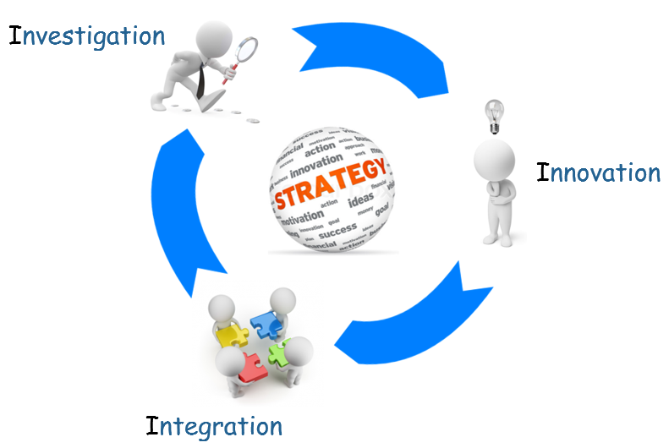
Strategic Management entails making long-range plans for organizations. This course utilizes business case studies to examine corporate strategies. Students are taught the strategic management process and apply that process using a sophisticated multi-period simulation throughout the term. Decisions are made from the perspective of top management. The course is designed to integrate and apply skills acquired throughout the business core curriculum. Global strategic management and corporate ethics are emphasized.

Semester Course Itinerary BUSN418
Day | TOPICS | EVENTS & ITEMS DUE
01 Mar | Introduction | Introduction to BUSN418 as a Study Abroad and class expectations
01Apr – 01May | Capsim Global Simulation | Introduction to Capsim Global – Complete Tutorials
01Apr – 01May | MFT, Pre-Tests | Complete the Major Field Test either independently or during a BUSN418 Exam time, Syllabus Quiz, Ethics Quiz, AACSB Quiz
1,2 04-05 May | Travel | Leave USA, Arrive Rome, Italy. Tour Rome, travel to Bologna
3– 06May | What is Strategy? Classical | Introduction; Capsim Introduction, Capstone Team Formation
4 – 07May | Leadership; Ethics | Capstone Global Practice 1.1(CGP1.1), Scholar Module Questions (SMQ), Team Charter
5 – 08May | Organization Design, Corporate Governance | CGP1.2, CGP1.3, SMQ,
8 – 11May | External Analysis, Internal Analysis | CGP2.1, CGP2.2, SMQ
9 – 12May | Competitive Advantage | CGP2.3, CGP2.4, SMQ
10 – 13May | Business Strategy – Differentiation & Innovation | Capstone Global Competition Year 1 (CGC1), SMQ
11 – 14May | Corporate Strategy – Integration and Diversification | CGC2, SMQ, Plant tour - Ferrari
15 – 18May | Capstone Mini Reviews | CGC3, SMQ
16 – 19May | Corporate Strategy – M&A  Global Strategy | CGC4, SMQ
17 – 20May | Strategy for Strategy | CGC5, SMQ, Capstone Presentation Outline
18 – 21May | Adaptive – Be Fast, Visionary – Be First, Shaping – Be the Orchestrator, Renewal – Be Viable | CGC5, CGC6, SMQ, AACSB Quiz , Plant Tour - Ducati
19 –22May | Capstone Presentation Prep | CGC7, CGC8, Capstone Presentation Review
20 – 23May | Capstone Presentations | Capstone Presentations; Capstone Peer Evaluation, Travel to Rome
21 – 24May | Travel | Return to USA

Course Requirements

Assignment | Points | Percent
Capstone Global – Strategy Simulation (45%)
Capstone Preparation (Tutorial) | 50 | 5%
Capstone Results (Profitability per round or approved Situation Analysis Write-up) | 150 | 15%
Capstone Team Peer Evaluation | 100 | 10%
Capstone Team Presentation (Preliminary 10k, Self-critique w/ video and Board of Advisors Presentations) | 150 | 15%
Other Class Work (55%)
Discussion & Participation | 150 | 15%
Plant Visit Preparation and Reports (Ferrari & Ducati) | 100 | 10%
Daily Module Questions (Scholar) % of average | 150 | 15%
MFT¹, Pre/Post Quiz (100,10,40), | 150 | 15%
Total | 1,000 | 100%
¹The MFT (Major Field Test) is to be completed the Spring Term prior to the Study abroad.
Extra Credit Opportunities (up to 10%, see notes below)
Capstone Team Rank (between industry; 15 for 1st, 10 for 2nd and 5 for 3rd based on total profit AND best balance score card for all classes: 25 for 1st, 15 for 2nd and 10 for 3rd ) | 25 | N/A
Resume (Center for Career Placement – review and update), Pitch | 10, 5 | N/A
Other Extra Credit (LSOBL (3pts each), LLS (3 pts each), Book Report (25pts each up to 2max) | . | N/A

Instructor Prerogative
Your instructor reserves the right to change any part of this syllabus. It is your responsibility to review it on Scholar/Blackboard.

Day | TOPICS | READINGS & VIDEOS
3– 06May | What is Strategy? Classical | Bledow - Learning From Others’ Failures - The Effectiveness of Failure Stories for Managerial Learning  Optional - Your Strategy Needs a Strategy, Chapter 2 (YSNS-2); https://www.youtube.com/watch?v=43kZDnyDXOc
4 – 07May | Ethics; Leadership | Banaji et al - How Unethical are you?  Optional - Campbell et al - Why Good Leaders Make Bad Decisions; Goleman - What Makes a Leader, https://youtu.be/tL_sQddBtU4?t=5,  Optional - https://www.youtube.com/watch?v=YOyk0KQP8js
5 – 08May | Organization Design, Corporate Governance | Wedell-Wedellsborg - Are you solving the right problems  Optional - Birkinshaw - Beware the Next Big Thing, https://www.youtube.com/watch?v=YlvuCWGPzOI https://www.youtube.com/watch?v=kMGe2WKD7jc
8 – 11May | External Analysis  Internal Analysis | Porter - The Five Competitive Forces that Shape Strategy; Kaplan and Norton - Using the Balanced Scorecard as a Strategic Management System  Optional - https://www.youtube.com/watch?v=dswljdE9B8Y , How should I analyze a company's financial statements?
9 – 12May | Competitive Advantage | Kim and Mauborgne - Blue Ocean Strategy
10 – 13May | Business Strategy – Differentiation & Innovation | Drucker - The Discipline of Innovation  Optional - Ben-Achour - Steels Decline; Ahuja - The Innovative Mindset Your Company Can’t Afford to Lose;
11 – 14May | Corporate Strategy – Integration and Diversification | Markides – To Diversify or Not to Diversify  Optional - Furr & Snow - The Prius Approach
15 –18May | Corporate Strategy – Mergers and Acquisitions  Global Strategy | Why would a company buyback its own shares?; McClure - The Basics Of Mergers And Acquisitions 2016,  Optional - https://www.youtube.com/watch?v=hPbGnNc3jO8, Zhang et al - Creating local Brands in Multilingual international markets; https://youtu.be/u95c_xKNVvw?list=PL7609FAD6BECAD94B&t=70, https://www.youtube.com/watch?v=ufcwosNE4jc , YSNS-1, https://www.youtube.com/watch?v=s2wL6bHtweA, https://www.youtube.com/watch?v=liQLdRk0Ziw,
16 – 19May | Strategy for Strategy | Bower & Christensen - Disruptive technologies: catching the wave  Optional - YSNS-3, YSNS-4; Stalk - Time--the next source of competitive advantage
17 – 20May | Adaptive – Be Fast, Visionary – Be First, Shaping – Be the Orchestrator, Renewal – Be Viable | Reeves and Bernhardt - Own the Future- 50 Ways to Win Chapter 3 – Systems  Optional - https://www.youtube.com/watch?v=LAzUUHsIyGk, https://www.youtube.com/watch?v=zUBJWAgPXdg’ https://www.youtube.com/watch?v=l1fodZNF1GI, YSNS-5, YSNS-6, YSNS-7; Chesbrough – Open Innovation; https://www.youtube.com/watch?v=i94dSA9E5-Y, https://www.youtube.com/watch?v=dC5lLcSK-1I
18 – 21May | Capstone Prep | Optional - Burke - What No One Tells You About Your Career When You are 22; Kawasaki and Walker – 10 – 20 – 30 Rule of PowerPoint

Learning Objectives
- Learn to apply discreet skills acquired throughout the business curriculum in a systematic and integrated fashion in order to improve business thinking and decision making. You should leave this class with a better understanding of the enterprise, its dynamics and the application of business thought. You should also feel more comfortable identifying, discussing and adjusting business strategies and assessing their impact on firm outcomes.
- Be able to integrate and apply discipline-specific concepts to formulate business strategies. Begin to understand the implication of decisions in one aspect of the business effect other aspects.
- Learn to analyze and critically evaluate ideas, arguments and points of view - develop critical thinking skills through active class discussions, assignments and the simulation.
- Acquire skills in working with others as a member of a team through group projects and team simulations.
- Be able to analyze any Fortune 500 company through the tools outlined in this course and provide a detailed report about that company’s strategy: both past (recent) and future.

Course Format
This course will be interactive, requiring class participation. PowerPoint and simulation software will be used to facilitate lectures. During and after lecture, we will have general discussions of the material and related case studies, and/or exercises/activities that demonstrate the concepts and allow you to apply these concepts. It is imperative that you participate in the in class discussions.
The multi-period simulation will be conducted in teams. Therefore, you must learn to work in teams and to plan and coordinate your schedule to include team meetings. At the conclusion of the course you will be reviewing and grading your team mates and they will be grading you. This simulation is designed to replicate, as closely as possible, the business management environment and challenges you will face in the real world.
This course will require your commitment and focus in order to be successful. I encourage you to consider your schedule over the semester and develop a plan for completing the assignments that are constructed to help you achieve the goals of this course.

Cultural Experience
During this study abroad, you will have two weekends to tour and travel in and around Italy. When traveling stay in groups of at least two or more and be sure one member has telephone access. If traveling out of the city, you are responsible for returning by class time the following Monday. Failure to do so will result in 10% reduction in class points awarded per day and minus 20 points on attendance.

Required Simulation Account
This course uses an advanced simulation program called Capstone Global® from Capsim Management Simulations. Inc®. All students are required to register with for the Capstone Global® simulation. You do this on-line at www.capsim.com. You will be required to agree to the Capsim terms of use and will have to use either a credit card or electronic transfer for payment. Details for signing up will be given during class. Additionally, you will automatically be signed up for two individual simulations: Comp-XM and Capsim-Inbox. Comp-XM is an assessment tool used to test your understand of basic business strategy and the implications of decisions. Comp-XM uses Capstone as a simulation asking you questions about the decisions you make. Capstone-Inbox measures soft skills and provides you feedback for self-improvement. The cost for the simulations are approximately $65.
Access code: Cxxxxx (do not select other sections – I will place you into your teams)

Required Reading
Reeves, M., Haanaes, K., & Sinha, J. (2015). Your Strategy Needs a Strategy: How to choose and execute the right approach. Harvard Business Press.
Ketchen, D., & Short, J. (2015). Mastering Strategic Management. University of Minnesota Libraries Publishing.

Optional Reading
Rothaermel, Frank, Strategic Management 3e, McGraw-Hill.
Most Strategic Management books cover the same topics. If you can find an inexpensive used or free online book it may aid in your initial analysis of your Fortune 500 Company.

Recommended Reading – “What’s New in Business?”
Be ready to discuss a new business story or situation in the corporate or non-profit business arena. You should be able to look at articles and relate them to the strategy of business. Your participation in “What’s New in Business?” reflects in your class participation grade. I will call on you randomly to share current (within the last few days) information about what is new and how it relates to strategy, the company you are researching and/or business.
You should be reading at least one of the following publications on a regular basis to increase your awareness of current events in the world of business. These include Business Week, Fortune, Forbes, Harvard Business Review, Inc., Investor’s Business Daily, The New York Times, U.S. News and World Report, The Wall Street Journal, Fast Company and The Washington Post. Also consider radio programs such as Planet Money and Market Place. And TV shows such as The Profit and Mad Money to name a few.

Reading Assignments
What you get out of this course depends on what YOU put into it. Do not underestimate the importance of preparation for each class. Please be sure to read the assigned chapters, cases and watch the videos before coming to class. This means you will have completed all assigned readings and are prepared to engage in serious discussion on the chapter material and cases. You will be responsible for material from the book, class lectures, and discussions on the exams. Additional handouts/articles/assignments may be given out during the term.

Module Questions
On Scholar each day are a series of questions about topics covered in the class, current events and Capstone simulation. Questions will be pulled from class lecture and discussions, current topics related to strategy, class readings, text books (required reading) and Capstone Global.
These questions are to be completed individually on Scholar before the end of each day. The questions will be presented in a multiple choice format. Choose the best answer for each question. There will be 10 to 20 questions per module and you will have 3 minutes per question once you start.
If you have any questions about what information is required, where to obtain the information or any other questions, feel free to contact me during office hours.

Grading Scale (preliminary)
Letter Grade | Percent | Description |  | Letter Grade |  | Percent | Description
A | 92.0-100.0 | Exceptional |  | C |  | 70.0-79.9 | Average
A- | 88.0-91.9 | Superior |  | D |  | 55.0-69.9 | Poor
B | 80.0-87.9 | Very Good |  | F |  | Below 55.0 | Failing

Please note: The assignments, quizzes and exams are designed to both test your comprehension of the subject matter and to push you to apply the information in more realistic and challenging settings. Therefore, grading is subject to your ability to show your mastery of the subject and application of the subject to specific questions on assignments, quizzes and exams. Your ability to demonstrate this knowledge of the subject matter listed in the learning objectives will determine your grade. Other important considerations are your participation in discussions, group work and extra credit. Quiz scores, assignment scores and extra credit aid in the determination of your grade. Note that you have a limited time to make a case for a grade change. After grades have been handed out or posted, you have one week to make the case that you should have received more points because your answer was correct.

Major Field Test (MFT)
The MFT is a requirement of the Luter School of Business. To graduate, you must take the exam. The School also requires that 10% of the BUSN418 grade be the results you receive on the exam. It is strongly suggested you attend review sessions and take practice tests. The MFT will be your final exam for this class. Please refer to the reading section on Scholar for more details. You will need to take the test the term prior to the Study Abroad (Spring 2020).

Peer Reviews
Throughout this course you may be required to complete peer evaluations. An early evaluation may be given and would be formative in nature. This means it would be used for feedback to determine if there are any situations regarding group work that need to be corrected. The review in the last couple of days of class is required and summative in nature. This means it is used for grading. This final review is through Capsim and is available the last few days. Failure to complete the final review will result in zero credit for that assignment.

Group Simulation - Capstone
You will team up into groups of 5. Each team will be required to develop and hand in a team charter describing the team, the team assignments, and the team methodology for making strategic decisions, dispute resolution techniques and method for entering decisions into Capstone®. Team charters are to also designate the CEO of the team and what the team wants to be measured against during the competition rounds (refer to the Capstone Courier for measurements).
Teams need to be diverse in nature. Research has shown that diversity in business simulates innovation and thus more diverse companies have higher long term returns. You’ll need to convince me your team is diverse. In most classes, teams will be required to have multiple majors represented in the class on the team (Majors (Management, Marketing, Finance and Accounting) and Minors).
All teams will be given control of an identically situated company in the sensor industry. You and your team will have complete control of the product development and R&D, the marketing and sales, the production and operations, and the finance functions of the company. The goal of the simulation is for you to analyze the industry and make strategic decisions to maximize shareholder value. You will have time for training and up to 4 practice rounds in the simulated industry and then 8 rounds of real competition against the other teams. Each round represents a nominal business year. An embedded industry journal, The Capstone Courier®, is updated after each round and you will see the results of your decisions.
I expect all members of the team to participate throughout the semester and in the preparation and delivery of the presentation. Each team member will evaluate their partners’ efforts on the team. I will periodically ask for team updates during the semester and will be available to meet with your team for consultations.
Each team will select a “CEO” or “president” or “senior director” to meet and communicate with me as your COB (Chairperson of the Board) as required (A/R). Choose a team member to fill this role who have excellent communication and organization skills. We will also meet in class. These meetings will be to review your teams’ strategy, analysis, projected decisions and progress on the team’s annual report and presentation. Meeting time in class is for your benefit and to aid in your decisions. Avoid simply coming to class for attendance and departing only to ask questions during office hours or other classes.
There will be two sets of practice rounds then the competition rounds. The practice rounds do not count toward grading. They are for you to practice the simulation and become familiar with how it functions. The competition round does count toward grading.
There will be homework assignments specifically geared toward the simulation, competition and understanding the business environment and the simulation. These are aids in understanding how the simulation and business works. Completing them will be beneficial to your outcome.
Your Preliminary Presentation will last 5 - 7 minutes followed by a Q&A session. There may be BOA members and faculty present during these presentations. You should have a 10k report accompanying this presentation. Watch, listen and/or read about company’s conference calls. This will give you an idea of what is expected. Prepare a short presentation of 4 to 6 slides. For this presentation you can pick who will present. You should discuss your current position (results) and your future outlook.
Create an Outline for your annual report. This should be the first step in setting up your presentation during the final week. You should place enough detail into this outline to have a good idea of the work needed to complete the Annual report and presentation.
Your Annual Report (Presentation) should be completed after round 7 and updated as required for the presentation of the Capstone challenge. Samples of annual reports are loaded on Scholar. Your report can be 8 to 12 pages (as your team sees fit). Longer is not always better. To simplify your work, your Annual Report is your presentation with additional content – thus think of the Annual Report as the written form of the presentation. Be creative and innovative while professional and concise. Be sure to include appropriate 10k information.
Your Final Presentation will last 12-20 minutes followed by a Q&A session and will be in front of other teams, juniors along with faculty and board members (in addition to myself). Consider Guy Kawasaki’s rules for presentations (on Scholar). Use your Annual Report as a basis for your presentation. Everyone in the final presentation must present and answer questions.
Your presentation will be about your results of round 7 and your decisions going into round 8. You will discuss your critical decisions relative to you current position, your company’s competitive advantage, your competitor’s advantages and disadvantages and your decisions for round 8 based on your proforma statements. The board will then vote to approve your decisions or not. This vote will be 25 points out of the possible 100 for the simulation results grade. Should the board not approve your proforma decisions you are to update your decisions and submit an executive summary for my approval.
Part of the requirement is your team attend all the other final presentations and score the other teams presentations. The rubrics for the presentation are on Scholar.
The end goal of the simulation is to learn how businesses operate and how decisions in one area can affect others (systems thinking). The main purpose in the learning environment is to understand the team’s successes and failures. This will be accomplished two ways. First, in the competition rounds, one of your objectives is to be profitable each round.
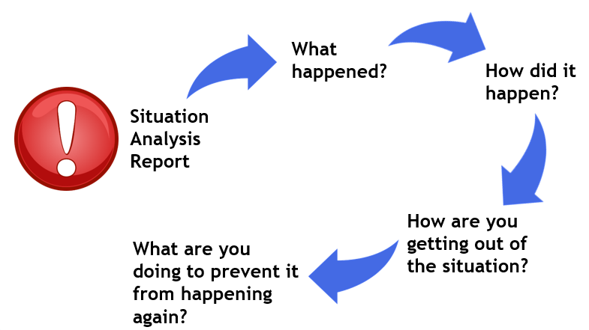
If you are not profitable, your team is to submit a detailed Situation Analysis Report of why the team was not profitable. This report should include what went well, what went wrong, why it went wrong, why it will not happen in the future and what the team is doing to recover from not being profitable. This report must include detailed analysis of the decisions that lead to the situation, detailed analysis of the decisions that will take the team out of the current situation and the financial numbers and/or flow charts to back up any claims. Your report should be at 8 to 12 pages (following the format below) and have backing data (in the form of charts, tables and graphs). This report is due in class the Monday after the simulation results are in (or the day before the next set of decisions are due – whichever is shorter). Your report needs to be approved to receive credit for Capstone for the week. If you do not submit an approved report, 20 points will be deducted from your Capstone performance.
The written situation analysis will be a report to closely mimic the corporate environment and should relate to the reading and/or class material and are designed to test your ability to reflect and apply retained concepts from the course.
Start your situation analysis with an Executive Summary. Most executives will read this and either throw the paper away or continue reading. Put extended time and effort into your summary. I strongly encourage you to write an outline for your paper prior to actually writing your paper.
See the Submission Check List in the reading section of Scholar and below.
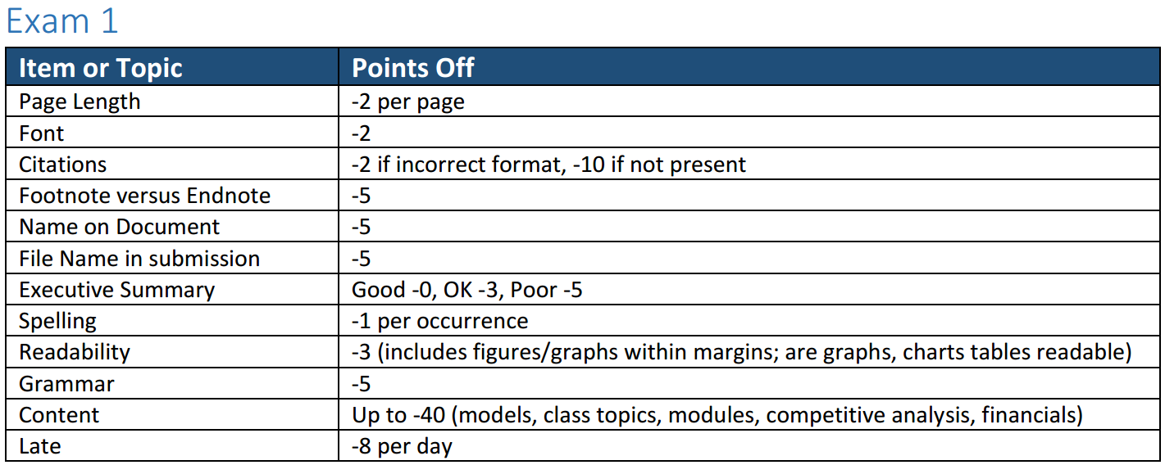

Class Preparation and Participation
Class participation is an important ingredient of the learning experience. Be prepared for every class. The classroom should be considered a laboratory in which you can test your ability to understand and conceptualize the problems and approaches, to present your analyses and recommendations clearly and persuasively, and to raise and address broader issues surrounding the specific problem context. You should let the instructor know before class if an emergency has made it impossible for you to prepare adequately. For cases, discussion and assignment questions will be provided before class or in the cases.

Random Assignments
Surprises and unexpected or unanticipated opportunities in the business world usually mean problems or opportunities. They happen. In a growing and expanding business they happen often and without warning. During the course of the term I will assign Random Assignments that you should be able to complete in a couple of hours. Random Assignments may count as part of your participation grade.

Attendance policy
Attendance is an absolute necessity to achieve the goals of this course and to succeed in business and life. Attendance will be noted.
Things are likely to come up that may make it difficult for you to make it to class (e.g. illness). Since there is no distinction between excused or unexcused absences, you should plan for the unexpected. The Luter School policy is six absences, for whatever reason, will result in an “F” for the course. I expect notification 1 hour prior to missing a class or immediately thereafter (in the case of illness). Unexcused or unannounced absences will result in 20 points each deducted from your discussion and participation grade per absence. Absences will also weigh against any team activities. There may be in class activities that are used for grading or extra credit. Those activities cannot be made up. It is not my responsibility to warn you about your attendance.
Late arrival and leaving early is disruptive to the instructor and to your fellow students, hence it is rude. Being late or leaving early is the same as not attending.

Classroom Etiquette
Consider the classroom like an office or boardroom. Treat each other with respect and allow for personal differences in opinion. Clean up when you leave. Please do not bring food into the classroom. Drinks and bars are acceptable.

Technology Usage and Policy
You need to become acutely familiar with the Microsoft Suite of products including Word, Excel and PowerPoint. Your reports should utilize the features of Word, your analysis of your corporation and Capstone should utilize the features of Excel and you will need to be proficient in PowerPoint for your presentation (also see Assignment Submissions below). You will also need to become familiar with the process and ability to share files between team members.
In the classroom (as in the office) the use of electronic devices (such as cell phones, laptops) can be distractive for other students and for the instructor. Do not text, tweet, chat, surf, watch videos or do other classwork in this class. When you arrive in the work place after graduation, your employer will expect you to be fully attentive to the job at hand – not your friends or hobbies. Working on other class assignments and studying for other class quizzes or exams is distracting to others. Working on other outside projects or interests is also rude and distracting. If you are not working on class activities, you will receive zero (0) points for participation for the course.

Communication - Scholar and Emails
Scholar and Capsim will be used extensively in this course to provide information and resources to help you get the most out of this course. You are expected to check your CNU email and Scholar regularly as any changes or announcements will be posted there. Capsim will also provide a number of assignments including peer reviews for the simulation, questions related to the simulation and decisions and tutorials.
Having an open dialogue and clear communication is essential in the business environment. If at any time you are confused or unsure – ask. Never ever assume. Anytime you cannot meet deadlines or requirements – negotiate with me (before the due date not after).

Extra Credit
Doing your job or the work assigned is great when you get to the corporate world. Separating yourself from others, however, requires going above and beyond what is “just necessary.” This course offers several opportunities to go beyond in the form of extra credit.
With regards to extra credit, you are to complete all the major assignments to receive extra credit. As in the work arena, you must complete your work first and foremost. Then you can receive extra credit for going above and beyond. If you do not submit a major assignment then you will receive zero (0) points for that assignment and cannot receive any extra credit points for the class. If you have five or more unexcused absences then you cannot receive extra credit.

Capstone Simulation
One way to achieve extra credit is to have your team do well in the Capstone Simulation. Points are awarded for most profitable per industry and best balance score card overall.

Lecture Events
Additionally you can attend Luter Slice of Business Life and the Luter Lecture Series and turn in a one page synopsis of the presentation within 48 hours following the rules below during the Spring term. If you cannot personally attend, you can write a two page synopsis of the company presenting and the background of the person(s) presenting.

Resume or Pitch
You can submit your resume for review and/or you can do a 2 minute pitch of You to the class. Your resume needs to be reviewed by the CPP. Provide a copy of the marked up resume from the CPP and the updated resume. See the date on the Calendar for the last submission date.

Book Report (Extra Credit)
You can submit up to two book reports.
You can purchase or check out from the Trible Library, read and write an executive book report on one or two of the books listed as optional reading. If you think you have another book that would be appropriate to strategy, propose that book to me for review. Your book report should be 4 pages double spaced (maximum), should include a brief executive summary, synopsis of the book subject matter and a paragraph on what you learned from the book. Also include proper citations. You can turn in your report any time after the first week and prior to end of week 12. You can turn in up to two (2) reports at 25 possible points each. Use the submission requirement noted below.

Choices for Book Report
Donaldson, W (2017). Simple Complexity: A management book for the rest of us. Morgan James Publishing
Spranger, A. N. (2018). Why People Stay: Helping Your Employees Feel Seen, Safe, and Valued. Routledge.
Doerr, J. (2018). Measure what Matters: How Google, Bono, and the Gates Foundation Rock the World with OKRs. Penguin.
Collins, J. C. (2001). Good to Great: Why some companies make the leap... and others don't. Random House.

Tzu, S. (2009). The Art of War: The Essential Translation of the Classic Book of Life. Penguin Publishing
Christensen, C. (2013). The Innovator's Dilemma: when new technologies cause great firms to fail. Harvard Business Review Press.
Osterwalder, A & Pigneur, Y (2010), Business Model Generation; a handbook for visionaries, game changers, and challengers. John Wiley & Sons.
Meadows, D. H. (2008). Thinking in systems. White River Junction, VT: Chelsea Green Publishing, 77-78.
Kotter, J. P. (2012) Leading Change. Harvard Business Review Press.
Mauzy, J., Harriman, R. A., & Harriman, R. (2003). Creativity, Inc: building an inventive organization. Harvard Business Press.
Trout, J. (2001). Big Brands, Big Trouble. Wiley & Sons
Welch, J., & Welch, S. (2009). Winning: The Answers: Confirming 75 of the Toughest Questions. Harper Collins.
Sinek, S. (2009). Start with why: How great leaders inspire everyone to take action. Penguin.
Aulet, B. (2013). Disciplined entrepreneurship: 24 steps to a successful startup. John Wiley & Sons.
Diamandis, P. H., & Kotler, S. (2012). Abundance: The future is better than you think. Simon and Schuster.
Carter, J. (2018). Faith, A Journey for All. Simon & Schuster.
Odom, L. (2018), Failing Up: How to Take Risks, Aim Higher, and Never Stop Learning, Feiwel & Friends
Gause, D., & Weinberg, G. (1990). Are your lights on. Dorset House.
Friedman, T. L. (2016). Thank you for being late: An optimist’s guide to thriving in the age of accelerations. Farrar, Straus and Giroux.
Hess, E. D., & Ludwig, K. (2017). Humility Is the New Smart: Rethinking Human Excellence in the Smart Machine Age. Berrett-Koehler Publishers
Dalio, R. (2017). Principles: Life and Work. Simon and Schuster (Note – Sections 1 & 2 or Sections 1 & 3)
Kiyosaki, R. (2017). Rich Dad Poor Dad: What the Rich Teach Their Kids About Money That the Poor and Middle Class Do Not!, Plata Publishing
Buffett, W. & Cunningham, L. (1997). The Essays of Warren Buffett: Lessons for Corporate America. The Cunningham Group & Carolina Academic Press.
Graham, B. (1949). The Intelligent Investor: The Definitive Book on Value Investing. HarperBusiness.

Assignment Submissions
Get in the habit of saving versions of files and using detailed file names. This will allow you to go back to older versions and pull information if you inadvertently deleted data or content.
Below are a list of submission requirements to follow for this class. Submitting an assignment with a only a file name of “exam” (for example) will be considered a non-submission. Submitting assignments without your name or team name and members is the same as not submitting the assignment.

Font/Spacing/Size
Use a sans-serif type font (such as Arial, Calibri or Helvetica) in an 11 or 12 size. Double space between lines. Left hand justify with 1 inch (25.4mm) margins.

References and Citations
Use endnotes when referencing sources or notes. APA citation method is universally known and accepted. However, others are acceptable. You may also consider a referencing software program such as Mendeley (https://www.mendeley.com/). You are to use and apply standard reference procedures. Never copy and paste other's work without providing full citations; only do so where appropriate. Most the work should be in your words not someone else's. References and citations can be single space and 8 point fonts to save space.

File Naming
Please use the following convention when submitting files:
Course Number Course Name Term and Year Assignment Title Your Name Version
For example –
BUSN418 Strategic Management Study Abroad Summer 2020 Paper your name or team name v3.pdf
BUSN418 Strat Mgmt SA Summer 2020 Paper your name or team name v6.pdf

File Type
Submit Word or PDF documents only. Be sure your document prints to the PDF or Word the way you want it to be viewed. I print these out in black and white so look at graphs and charts in black and white before submitting. Double check your submission to be sure the visual on your computer matches what is shown on scholar.

Use of Word, Excel and PowerPoint
As seniors in college, you should have a strong command on the use of Microsoft Word. Use headings, endnotes, split paragraphs, photo, table, graph insertion techniques to create a professional looking paper.
Excel (Windows based) is the spreadsheet of choice in corporate America. You should be able to navigate the commands, write formulas and create charts and graphs. The library has computers that work well with this software.
PowerPoint use in corporate America considered essential. Carefully choose backgrounds, fonts, colors and presentation mode to fit the business, clients and audience.

Luter School Mission
Cultivating Liberally Educated Business Leaders
Our mission is to develop undergraduate students intellectually, professionally, and personally through a rigorous liberal arts-based, applications-intense program that distinguishes them as critical thinkers, collaborative problem-solvers, articulate communicators, and ethical business leaders who possess the multidisciplinary competencies and specialized skills necessary to impact their community, the region, and the global economy. Quality is assured by maintenance of accreditation with AACSB International.

Success at Christopher Newport University
I want you to succeed in this course and at CNU. I encourage you to come see me during office hours or to schedule an appointment to discuss course content or to answer questions you have. If I become concerned about your course performance, attendance, engagement, or well-being, I will speak with you first. I also may submit a referral through our Captains Care Program. The referral will be received by the Center for Academic Success as well as other departments when appropriate (Counseling Services, Office of Student Engagement). If you are an athlete, the Athletic Academic Support Coordinator will be notified. Someone will contact you to help determine what will help you succeed. Please remember that this is a means for me to support you and help foster your success at CNU

Christopher Newport University Honor Code
“On my honor, I will maintain the highest standards of honesty, integrity and personal responsibility. That means I will not lie, cheat, or steal and as a member of this academic community, I am committed to creating an environment of respect and mutual trust.” (Student Handbook, p.10).
The CNU Honor Code is enforced in this class. Every student is expected to model ethical behavior and lead by example. All work submitted in this course for a grade is subject to the CNU Honor Code. All work is to be solely that of the individual student, except for projects explicitly designated as team projects. Willful plagiarism or any other violation of the CNU Honor Code will result immediately in a grade of "F" for the course and disciplinary action.

Disabilities
In order for a student to receive an accommodation for a disability, that disability must be on record in the Dean of Students’ Office, 3rd Floor, David Student Union (DSU). If you believe that you have a disability, please contact Dr. Kevin Hughes, Dean of Students (594-7160) to discuss your needs. Dean Hughes will provide you with the necessary documentation to give to your professors.
Students with documented disabilities are required to notify the instructor no later than the first day on which they require an accommodation (the first day of class is recommended), in private, if accommodation is needed. The instructor will provide students with disabilities with all reasonable accommodations, but students are not exempted from fulfilling the normal requirements of the course. Work completed before the student notifies the instructor of his/her disability may be counted toward the final grade at the sole discretion of the instructor.

Physical Requirements
Italy is not ADA compliant. There will be many locations that require walking on rough and un-even surfaces. Many facilities and hotels do not have elevators and will require walking up and down stairs. Additionally, many buildings are more the 200 years old and are historical in nature. Steps and pathways will be worn, uneven and poorly lit.
The student will be required to handle their own luggage. This includes lifting the luggage onto and into vehicles, moving luggage to and from rooms and traveling (walking) several city blocks from transportation stations to hotels.

Travel Requirements
The fees for this study abroad are based on double occupancy. If a student elects to do single occupancy the student asking for single occupancy will be responsible for the additional room changes associated with single occupancy.

Academic Support
The Center for Academic Success offers free tutoring assistance for CNU students in several academic areas. Staff in the center offer individual assistance and/or workshops on various study strategies to help you perform your best in your courses. The center also houses the Alice F. Randall Writing Center. Writing consultants can help you at any stage of the writing process, from invention, to development of ideas, to polishing a final draft. The Center is not a proofreading service, but consultants can help you to recognize and find grammar and punctuation errors in your work as well as provide assistance with global tasks. Go as early in the writing process as you can, and go often!
You may drop by the Center for Academic Success to request a tutor, meet with a writing consultant, pick up a schedule of workshops, or make an appointment to talk one-on-one with a University Fellow for Student Success. The Center is located in Newport Hall, first floor, room 123.

