Ecology, Geology and Cultural Significance Yellowstone and Grand Teton National Parks

Instructor: Dr. Jeff Groff (jgroff@shepherd.edu)
Office Hours: By Appointment, Byrd Science Center 116
Meeting Times: TBD
Classroom: TBD
Cost: est. $400 + tuition + airfare

I. Course Description

In 1872, Yellowstone National Park became America’s, and the world’s, first national park. It is an otherworldly place of geysers, hot springs, waterfalls, and canyons. It is an ecological treasure where megafauna such as bison, elk, grizzly bears, and wolves roam free. Its origin reflects the emergence of efforts to conserve and protect wild places in America and the birth of a wilderness-for-its-own-sake ethos. Its history echoes the often violent and unjust collision between encroaching peoples of European decent and native cultures during American westward expansion.

This course will explore the ecology, geology, and cultural significance of the greater Yellowstone area through readings, discussions, and a field excursion to Yellowstone National Park and Grand Teton National Park. The field excursion will be July 16th through July 25th. We will spend one night at Mink Creek in the Caribou-Targhee National Forest in state park in south-eastern Idaho, five to six nights at Yellowstone National Park, and two to three nights at Grand Teton National Park. In addition to tuition, students will be required to purchase an airline ticket and pay an $400 course fee to cover food, camping, and other costs associated with the field excursion costs. Go to the Study Abroad Office website for this course (https://goo.gl/1dlV2B) and click on the Apply to this Program button to pay the fee. The due date is April 28th, 2017. For environmental studies majors, this course will substitute for ENVS 368 (4 cr) or an appropriate alternative major requirement. All other students can count the course as upper division elective credits.

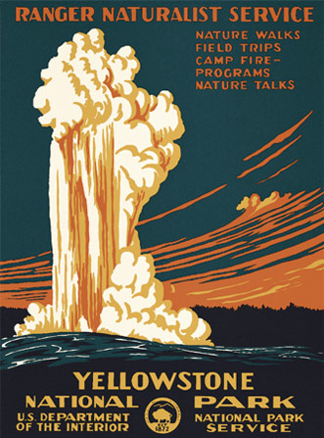
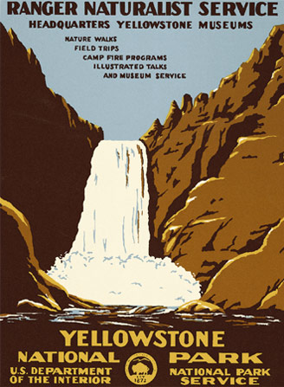

II. Course Requirements

Students are required to participate in a field excursion to Yellowstone and Grand Teton National Parks as part of this course.

Course Materials

Robert Smith and Lee Siegel, “Windows into the Earth: The Geologic Story of Yellowstone and Grand Teton National Parks”
ISBN-13: 978-0195105971

Douglas Smith, “Decade of the Wolf, Revised and Updated: Returning the Wild to Yellowstone”
ISBN-13: 978-0762779055

George Black, “Empire of Shadows: The Epic Story of Yellowstone”
ISBN-13: 978-0312383190

III. Grading

Participation (50 %)

This portion of the course grade will be based on attendance, evidence of completion of assigned readings, engagement in the classroom and on the field excursion, and contributions toward the planning and execution of the Yellowstone and Grand Teton trip.

Journal (25 %)

While in the field, each student will compose a daily journal entry in a composition book (1 page for each day). Entries will summarize the day’s activities but also include personal reflection and citations to tie the day’s experience to course readings.

Test (25 %)

One test will be given to assess learning of key terms, facts, and concepts from readings, discussions, and lectures.

IV. Course Timeline

Week(s) | Dates | Tentative Schedule
1-3 | 5/21-6/7 | Empire of Shadows, Culture of Yellowstone
 | TBD | Course Overview
 | TBD | Group Hike 1
4-5 | 6/8-6/21 | Decade of the Wolf, Ecology of Yellowstone
 | TBD | Planning and Gear Check
 | TBD | Group Hike 2
6-7 | 6/22-7/5 | Windows into the Earth, Geology of Yellowstone
 | TBD | Field Excursion Preparations
 | TBD | Group Hike 3
8 | TBD | Exam
 | TBD | Packing and Field Excursion Staging
 | TBD | Group Hike 4
9-12 | 7/16-7/25 | Yellowstone and Grand Teton Field Excursion (See Detailed Itinerary Below)
 | TBD | Unpacking and Gear Check
 | 8/2 | Travel Journals Due

Detailed Yellowstone and Grand Teton Field Excursion Itinerary
Date | Travel Plans | Camp Location
Tues. 7/16 | SU to BWI to SLC to CTNF | CTNF (Mink Creek)
Wed. 7/17 | CTNF to YSNP | YSNP (Bridge Bay)
Thurs. 7/18 |  | YSNP (Bridge Bay)
Fri. 7/19 |  | YSNP (Bridge Bay or BC Pebble Creek)
Sat. 7/20 |  | YSNP (Madison)
Sun. 7/21 |  | YSNP (Madison)
Mon. 7/22 | YSNP to GTNP (Contingency) | YSNP (BC Fairy Creek) or GTNP (Colter Bay)
Tues. 7/23 | YSNP to GTNP | GTNP (Colter Bay)
Wed. 7/24 |  | GTNP (Colter Bay)
Thurs. 7/25 | GTNP to SLC to BWI to SU | Home
SU – Shepherd University, BWI – Baltimore-Washington International Airport, SLC – Salt Lake City International Airport, CTNF – Caribou-Targhee National Forest, YSNP – Yellowstone National Park, GTNP – Grand Teton National Park, BC – Back Country Overnight

V. What to Expect

The field excursion to Yellowstone and Grand Teton will involve camping and a good deal of hiking. The climate of Yellowstone National Park is influenced by elevation and topology. In July expect partly cloudy to mostly sunny days with low humidity and highs in the low to mid 70’s. Afternoon thunderstorms are not uncommon and weather systems can move through that bring extended periods of rain. Alpine weather is notoriously unpredictable. Expect dramatic temperature swings and sudden showers, especially at higher elevations. Nighttime lows can dip into the 30’s.

Tent camping and hiking in Yellowstone and Grand Teton National Park can be a somewhat primitive experience. Expect pit toilets in the campgrounds and on trails although flush toilets are located at many popular sites and visitor centers. Potable water is readily available from outdoor faucets. Shower and laundry facilities are available near the campgrounds, but don’t expect to have the opportunity to shower every day.

VI. Essential and Recommended Gear

While tents and other camping gear like stoves will be provided, there are other items you will be responsible for bringing.

Essentials:

- sleeping bag (a 20-30 degree bag that weighs under 4 lbs. is ideal)
- rainwear (separate jacket and pant)
- backpack (a lightweight 50-70L internal frame bag with water reservoir compartment is ideal)
- water reservoir (e.g., Platypus 2-3 L)
- flashlight (LED headlamps work great)
- broken in hiking shoes/boots
- sunscreen

Recommended:

- sleeping pad (e.g., lightweight backpacker’s inflatable)
- compressible pillow
- water bottle (e.g., 1L Nalgene)
- thermals
- wool or synthetic hiking socks (several pairs)
- insect repellant
- pocket knife or multitool
- water shoes
- bonnie-style or other wide-brim hat
- fleece jacket or vest
- lighter or matches (campfires may be prohibited depending on weather and location)
- camera
- wrist watch

