**SUMMER SESSION 2019 in EUROPE**

**Hist. 360/Pol. Sci. 432**

May 14 – June 6

EVOLUTION OF EUROPEAN GOVERNMENT AND SOCIETY

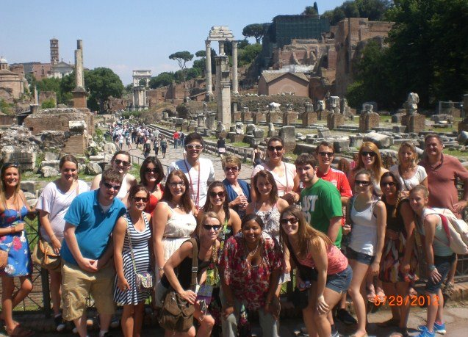

**The Course**

This **6 credit hour** study abroad course will include 24 days of travel to Italy, Belgium, the Netherlands, Greece, Spain and France.

The program will employ hands-on learning to provide students with an experiential understanding of the history of early political thought and political systems. This is not your typical study abroad course where students go to a foreign country and take classes at a host university. It is a holistic approach that maximizes the international experience.

The holistic experience means students should get an appreciation of not only the history of European political systems, but gain an understanding of European society and culture both past and present. To achieve this end, we will not only focus on historical trends of various states, but also compare these with contemporary issues. In addition we will consider changes in culture and society as depicted in the art and architectural treasures of Europe.

The course will focus on how political structures and political theory have evolved. The course will begin with an exploration of early civilizations (Minoan, Greek, Roman) and then progress to the medieval and early modern European states. It will conclude with an examination of the evolving structures of the European Union and the security arrangements under NATO. Special emphasis will be placed on providing a better understanding of contemporary political/societal structures and thought.

**Course objectives**

* To provide students with an understanding of the evolution of political systems from Ancient Greece to the European Union.
* To provide students with a better understanding and appreciation of the value of history and culture.
* To enhance and sharpen analytical abilities and communication skills. To make students think and re-examine their own goals, aspirations and values.
* To create an insatiable appetite for knowledge.

#### The Instructors

Professors Dr. Sally Brasher and Dr. Niel Brasher will conduct the program. Sally is an Associate Professor in the Department of History at Shepherd University. Sally has done extensive research in Italy and teaches courses on European history. She has published two books and presented numerous papers on the history of many of the places we will be visiting. Niel is a Professor in the Department of Political Science at Shippensburg University. He spent two years running American University's highly successful study abroad program in Brussels and offers courses in International Politics. The Brashers have led over 20 different university groups to Europe.

# **Orientation /Online Work**

Before departing we will administer an intensive set of online orientation classes. This will include a survey of European history from the Roman Empire to the present, including an introduction to the various political systems and an overview of what to expect from an international experience. In addition, current trends and various cultures will be examined in order to understand the current context and the culture of the places we will be visiting. Students will obtain a basic knowledge of political economy and the international governmental organizations crucial to trade and security. An emphasis will be placed on examining the many current controversies in these areas.

This is a six credit-hour experience; thus, the online component will have examinations, paper assignments, readings and other exercises.

#### Tentative Itinerary

We will be flying out of Newark Airport and returning there. Students will be responsible for getting to and from the airport.

**Italy Siena/Florence/Rome**

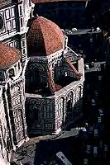**Siena/Florence**



Sienais a college town that, apart from having a beautiful and active city center called the Campo, contains numerous interesting sites. We will discuss the various governmental structures of these Renaissance city states and enjoy their historical treasures. In addition, we will use Siena as a launching pad for a day trip to Florence. Students will be given a tour of the Uffizi Gallery, which houses the major art treasures of the Renaissance. In addition they will be given tours of several palaces and churches in the city.

**Rome**

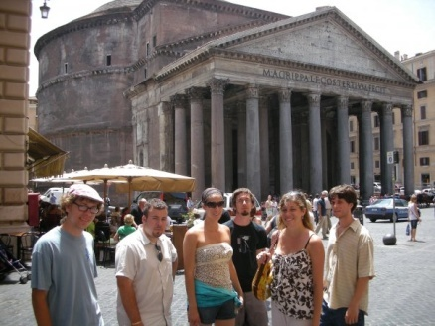We will spend three days in Rome. As Ancient Rome has been the model for many of our western institutions of government, society, and culture, it is a great place to start in order to understand the heritage of European institutions. While in Rome, we will visit the site of the ancient Forum, Coliseum and other famous ruins. We’ll also tour the Vatican Museum to see the treasures housed there, as well as develop an understanding of the role of the Church in European history.

**Belgium**

**Brussels**

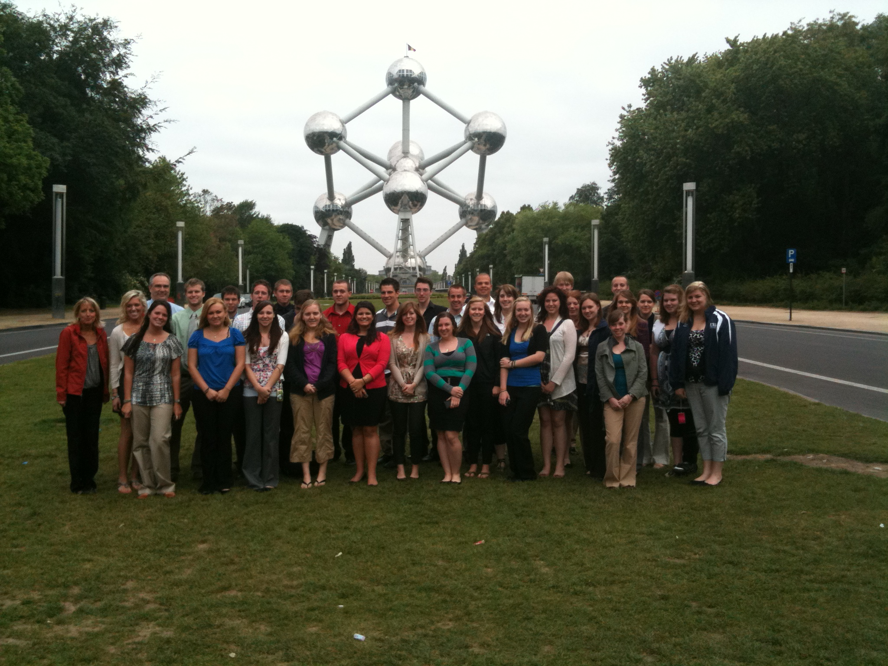Modern Belgium encompasses an area that has been claimed by all the major powers of Europe. During the Renaissance its cities, including Brussels, were part of an international commercial center and felt the influence of the great Italian, Dutch, and English Renaissance thinkers and artists. Brussels is also conveniently located within a three-hour train ride to Paris, Amsterdam, and many other destinations in France, Germany, Holland, and Belgium.

While in Brussels students will be staying with host families. These host families will all be situated around the northern suburb of Brussels in two small towns called Alsenburg and St. Genesis-Rhode.

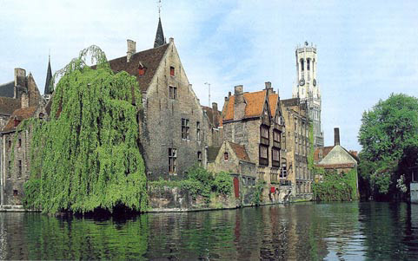The focus of the course in Brussels is to gain knowledge through meeting with decision-makers and visiting sites. Examples of what we will be doing:

* Taking a city tour of Brussels highlighting the political and historical developments of the famous Grand Place and tracing Belgium's role in European history overall.
* Visiting the beautiful medieval town of Bruges.
* Several guest lecturers will discuss Belgian history and its role in modern Europe.
* We will also study the state of modern European integration with visits to NATO and SHAPE headquarters, including a meeting with NATO officers.
* Visiting to the former WWII concentration camp of Brendonk.

**France: Reims/Paris**

We will stop in Reims, capital of the famous Champagne region of France and visit historic Reims Cathedral.

We will spend two days in Paris where we will visit many historical sites and hear lectures on how the City of Lights contributed to the political and social culture of Europe both in the past and today.

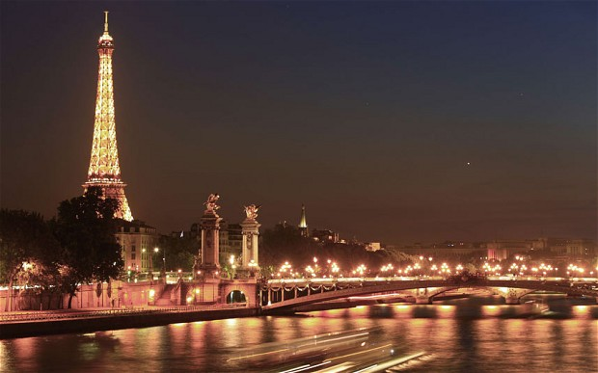

**Greece**

**Athens free time in Santorini**

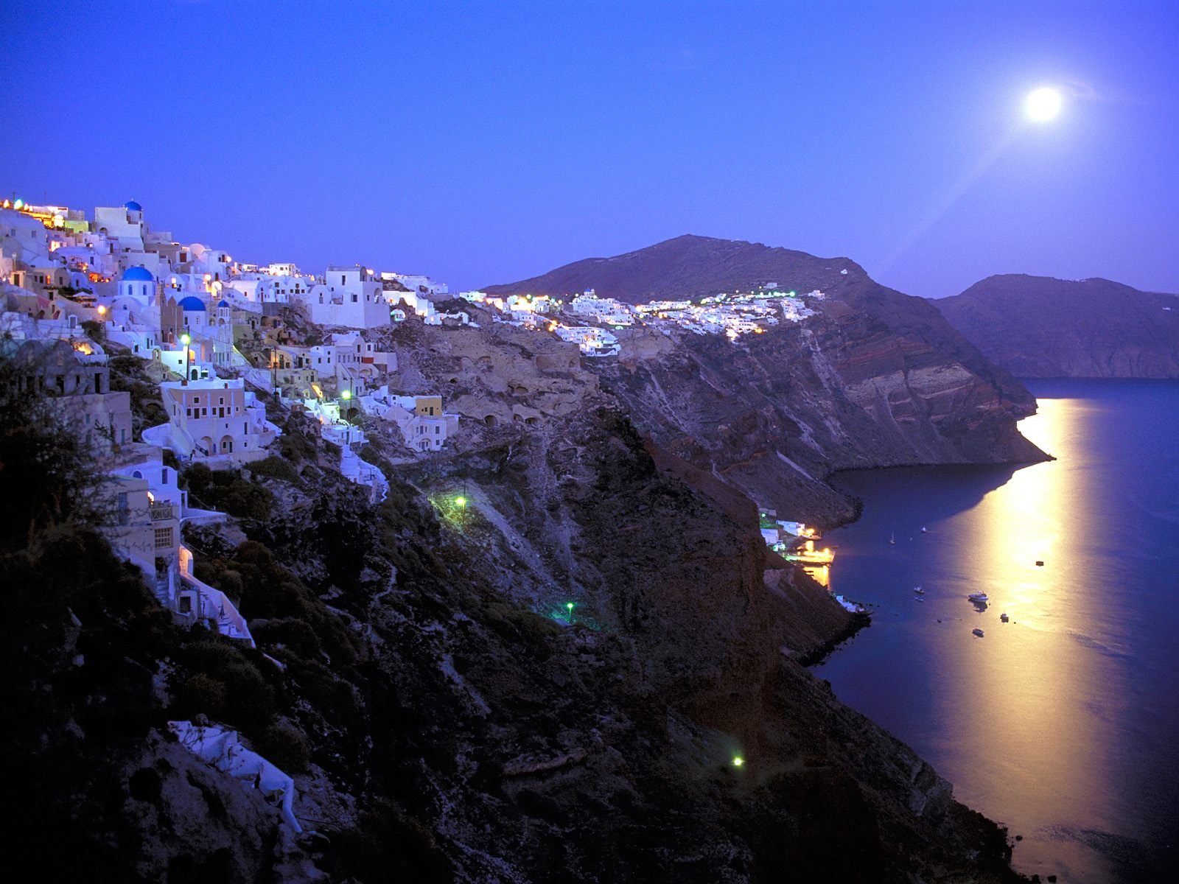

**Free time**

You will be given three days on the volcanic island of Santorini;. You will be responsible for finding lodging for threse days, but in late May and early June, lodging tends to be reasonably priced and abundant.

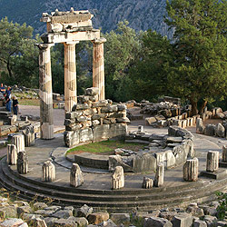

**Athens**

We will arrive in Athens and stay for two nights. Athens is the birthplace of western civilization and we will visit the Acropolis and Forum and discuss the contributions made by the classical Athenians to politics and cultures. We will tour the Agora and the famous Acropolis Museum. Students will also have a chance to visit the famous Plakia neighborhood with its medieval streets and busy modern nightlife.

**Spain**

**Barcelona**

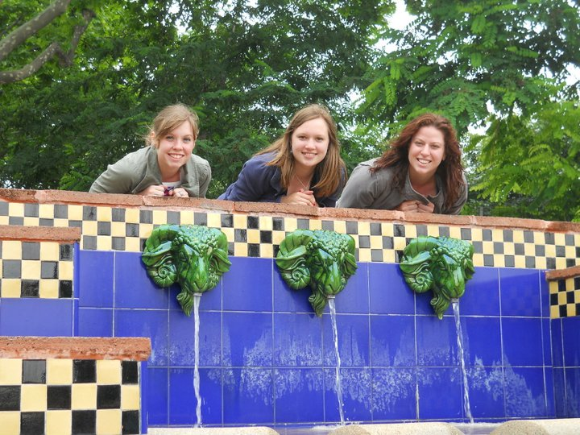In Barcelona we will consider the political and social implications of the divide between the Spanish and Catalonian cultures. In addition we will explore the fascinating architectural treasures of Barcelona from the original Roman walls encompassing the old medieval city to the early 20th century modernist movement architecture of Gaudi, in order to view the overlapping styles and their contributions to the city over the centuries. A favorite activity is walking down the famous Rambla avenue before heading over the chic beaches for sun and swimming, volleyball or people watching at one of the many seaside cafes.

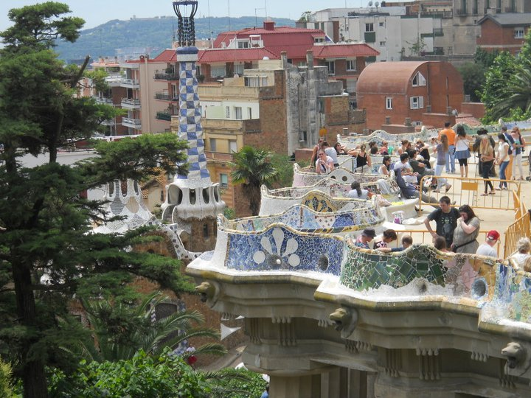

**Academics**

The classes are one three credit hour course in European history and one three credit hour course in Political Science titled *The Evolution of European Government and Society.* Students will be asked to complete intensive Sakai online work before departure and more Sakai work after the program has been completed. This will include readings, papers and examinations. While in Europe students will be required to keep an academic journal, where they react to tours, sites, readings and culture. Some of their reactions will be directed through questions from the instructor.

**Program Costs**

Program costs (includes: airfare, lodging, field trips, entrance fees, activities, some meals, transportation in Europe) are $3875 per student. **In addition, students will need to pay tuition for the six credit hours**. Students taking six credits or more in the summer are eligible for financial aid loans — including program costs. Students must secure their own passports.

**Eligibility and Rules**

Typically we recruit students from a variety of backgrounds. While there are many political science/history students, they normally make up only half the trip membership. There are no academic pre-requisites for this trip. We look for people who are in good academic standing (i.e.. no where near probation) and have a good attitude. We are looking for students who interact well with others and have an open mind toward learning. We can and will teach you everything else. Students learn a great deal about politics, history and economics, but they report learning much more about cultures and themselves.

We find this type of program attracts a wide variety of interesting people who self-select themselves by their eagerness to take the risk to go on such a trip. Historically we have had almost 100 percent satisfaction rates. Most report it is the most valuable learning experience they have had in college.

We are teachers and facilitators, not chaperones. Students are treated like the adults they are. The few rules we have consist mostly of the need to treat others (locals, tour guides, bus drivers, colleagues) with respect; attend all sessions (everybody always does); be attentive at all sessions; no drugs and no excessive drinking. Students who violate the rules will be dismissed from the program and must make their own way home.

We will use a variety of forms of transportations. Students will be responsible for carrying their own luggage and keeping track of their personal belongings.

## Application

A $300 non-refundable deposit* is required with your application. Applications will be taken until the program is filled. Make your check out to **Shippensburg University**/Brussels Study Abroad. The program is limited to 20 students. Airfare ( aprox. $900) will be due February 1, 2019. The balance will be due May 1. Please apply as early as possible. To apply go to the Shepherd University Study Abroad Web page to the left hand side to program type, under Shepherd exchange programs look for ours and hit apply. You will be asked to create a profile. If you have questions or problems contact Dr. Brasher at sbrasher@Shepherd.edu.

## Additional Information

If you have any questions, please contact:

Prof. Sally Brasher

Department of History

Knutti 114d

Sbrasher@shepherd.edu

“I never thought in a million years I would make it to Europe. I come from a rural background and I was the first in my family to see what was across the Atlantic Ocean. I would not trade the three weeks I spent on this trip for anything in the world. I learned not only the fundamentals of European government, but also about myself and how I can adjust to many different situations. I feel like I can accomplish anything!”

Jessie Sigley

Student Government Association President