Politics, Culture, and the History of “Senegambia:” a Study Abroad Tour, March 2019

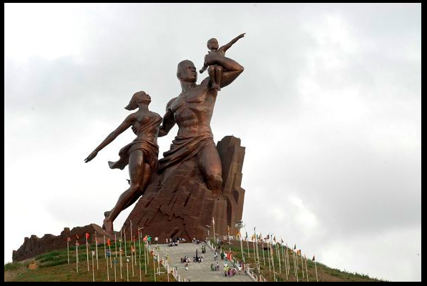

History and Sociology 399 C (CRN ###)
Spring Semester 2019
Three (3) Credit Hours
Time/Location of Class TBA

Primary Instructor: Dr. E. M. Perego
Office: Knutti Hall 115D
Office Phone: 304-876-5309
Email: eperego@shepherd.edu
Office hours: Wednesday and Friday from 12:00 pm to 3:00 pm

Course Description

This course will help students to prepare for the March 2019 Shepherd Study Abroad Trip to Senegal and the Gambia.

Goals and Learning Outcomes (LEAP)

Learning Outcomes:

Students in these courses will…
- understand chronology and the process of change over time;
- compare historical experience across time, place, and culture;
- understand historical developments in their political, cultural, social, and economic
contexts; and understand the interconnectedness of these contexts;
- understand that the assessment of historical causation emanates from multiple
perspectives—that there is no one “correct” explanation of change;
- evaluate primary sources as a key to understanding the past;
- understand the nature of contingency

Student Performance Assessment

Student performance will be evaluated based on:
- mastery of course content
- ability to think critically about and engage with course material
- written and oral expression of ideas

Course Requirements

Attendance

You MUST attend your classes regularly and engage in the requirements for each class; otherwise, your financial aid may be revoked either partially or in full. This would result in an amount due by you to the University immediately. Please refer to shepherd.edu/faoweb for more details.

Required Readings

Sembène, Ousmane. Gods Bits of Wood. Pearson: 2008. ISBN 0435909592.

This book is available at the Shepherd University Bookstore.

How will my grade be calculated?

Participation 50%
Reflection paper 30%
Journal 20%

Participation

To earn the 50% of your grade that goes towards participation, you must actively engage in class discussions and activities. You must also attend, take notes, and participate in at least one University lecture in Dakar. You are expected to take notes on/follow information provided during site visits closely.

Reflection Paper

Upon returning to the U.S. after you trip to Dakar and Banjul, you will compose a three to five-page reflection paper outlining your overall experience abroad. The reflection should be broken down as follows and should include proper citations:

1-2 pages:

1-2 pages: choose one aspect of the trip and write specifically about what you learned through that experience and how you can relate it to your goals for personal and/or professional growth goals

1 page: Review of one of the readings/assignments/tour visits of the trip

More instructions will be posted to Sakai and outlined as we move forward with the semester.

Journal

Students will keep a journal of their experiences during the Dakar and Banjul trips. Students are expected to make at least one paragraph-long entry per day between March 8th and 17th.

Academic Integrity

Each student in this course is expected to abide by the Shepherd University Academic Integrity Procedures found in the Shepherd University Student Handbook (http://www.shepherd.edu/wordpress-1/wp-content/uploads/2016/10/StudentHandbook.pdf ).

Students who plagiarize or commit any other form of academic misconduct will receive a zero for the assignment in question. I will also report all incidents of academic misconduct to Shepherd University Administration and they will keep these incidents on your academic record.

Disability Support Service and Other Resources
The Office of Disability Support Services at Shepherd University believes that, "the first step to success is access." Disability Support Services is committed to working closely with individuals with exceptionalities to meet their academic and housing needs. Students requesting any disability related accommodation should contact the Office of Disability Support Services at 304-876-5122. This includes, but is not limited to students with visual or hearing impairments, students with diagnosed disabilities that affect their learning and in need of academic accommodations, and students requesting specific housing accommodations for health-related reasons. Students must be registered with the Office of Disability Support Services and present their certified accommodation letter to each of their instructors as early in the semester as possible prior to using any granted academic accommodation. For more information, please visit http://www.shepherd.edu/disability
FREE TUTORING! ANY COURSE! TAKE ADVANTAGE OF A FREE “PERSONAL TRAINER FOR THE MIND!” In 103 Library: www.shepherd.edu/ascweb; 876-5221; 8:00 am–4:30 pm.

Students are encouraged to sign up for “RAVE alerts” (http://www.shepherd.edu/university/rave/) in order to be informed of campus closures. Also, students are encouraged to check the Shepherd website for additional information (http://www.shepherd.edu/).

For this course, we will use the Sakai Learning Management System (courses.shepherd.edu)
Tutorials and other helpful information may be found at: http://www.shepherd.edu/ctl/instructional_tech/sakai.html

Make-up Exams and Late Assignments

I permit students to make-up exams or turn assignments in late only if they have experienced a documented emergency. Please send me an email with documentation of your emergency in the event that you do need an extension on work or to make-up an exam and we will make arrangements accordingly. Please note that any missed exams will need to be made up the last week of classes.

Course Schedule

Monday, January 14th: Introduction to study abroad

Read together: beginning of the Hobbit

Monday, January 28th: Safety and health considerations

Review: CDC and State.gov recommendations for Senegal and the Gambia
Register with: State Department Smart Travel Program for Senegal and the Gambia
Fill out: Gambian visa applications (bring $100 money order and passports)

Monday, February 11th: Local customs and practice handling situations

Read: Selection from The Study Abroad Handbook

Monday, February 18th: Basic French and basic Wolof

Go through: Peace Corps handbook for Wolof

Monday, February 25th: Overview of the history, culture, and politics of the Senegambia

Watch: Xala (possibly with Dr. Perego’s 399A course or with Shepherdstown Film Society)

Read: God’s Bits of Wood

Friday March 8th: Travel to Dakar, Senegal from Dulles International Airport

Saturday, March 9th: Orientation at WARA, trip to Goree Island and la Maison des Esclaves, first night in homestay

Sunday, March 10th: Tour of downtown Dakar and concert

Monday, March 11th: Lecture at University of Cheikh Anta Diop on Senegambian politics, meeting with Senegalese students

Tuesday, March 12th: Visit to the Dakar Railway Station, lecture on Senegambian labor history, finish day at University of Cheikh Anta Diop

Wednesday, March 13th: Day to shadow Senegalese student at the University of Cheikh Anta Diop, IFAN African Arts museum late afternoon

Thursday, March 14th: Trip to Banjul, the Gambia, overnight at local hotel

Friday, March 15th: Return to Dakar, trip to Senegalese National Archives, and last visit to WARA

Saturday, March 16th: Last day in Dakar, debrief at the University of Cheikh Anta Diop, farewell dinner with families

Sunday, March 17th: Departure from Dakar to Dulles Airport

Monday, March 25th: Debrief of trip and review of journal and journal grading

Final reflections due to Sakai by Friday, April 26th

