PERU SUMMER 2018!
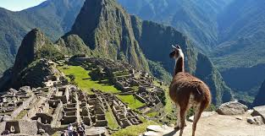
Cusco, Peru
Four Weeks (May 28-June 23)
$3,700*
Join us in what will be the biggest, most exciting adventure of your life! You will:

-Earn six-credit hours.

-Live in Cusco, the ancient capital of the Inca empire.

-Spend a weekend in Machu Picchu.

-Experience the Andean culture.

-Go river-rafting.

Contact:
Dr. Urroz (urroze1@citadel.edu)

-Go ziplining in the Peruvian rainforest.

-Be a part of an ancient ritual led by a Quechua Shaman.

-Experience daily life with a Peruvian family.

-Improve your Spanish.

-Become exponentially more attractive to future employers.

Dr. Roca-Martínez (srocamar@citadel.edu)

