Mexico Maymester 2016
May 9-28, 2016, Mexico City and Guanajuato, Mexico

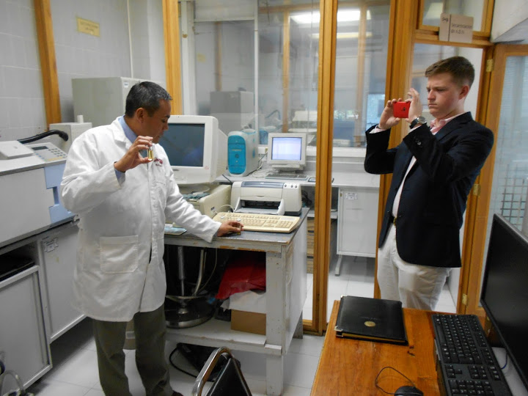
Interview security experts Mexican National Penal Institute crime lab
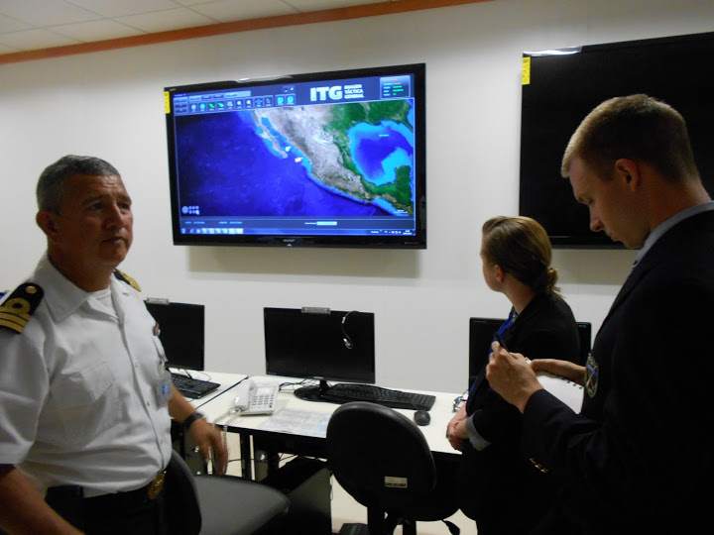
Service learning in activity near Guanajuato Mexican Naval Postgraduate Institution

3 hrs. CRMJ 465 academic credit (cluster A credit for criminal justice majors; general elective for non-criminal justice majors)
No Spanish required. All majors welcome.

Mexico is a country with a population of 115 million, is the US’s third largest trading partner, and shares a number of security and economic concerns with the US. The Mexico Maymester 2016 program is an intensive introduction to Mexican culture, history, and institutions. The centerpiece of the program is a series of 25-30 mid- and high-level interviews with Mexican security experts, policy analysts, and both US and Mexican officials in the 20 million person Mexico City. Students will also gain an appreciation for representative circumstances of Mexicans living outside the capital city through a service learning and homestay activity in scenic Guanajuato.

Autonomous Technology Institute of Mexico (ITAM)
National Autonomous University of Mexico (UNAM)
Colegio de Mexico
Center for Economic Teaching and Research (CIDE)
Mexican Congress
Mexican Senate
Mexican Supreme Court
US Embassy
US security firm operating in Mexico
Mexican penal system
Mexican Census Bureau (INEGI)
visit: http://www.citadel.edu/root/criminaljustice-studyabroad
contact: Dr. Brian Norris, bnorris@citadel.edu, (843) 214-4690

