IDIS 280
Special Topics in Interdisciplinary Studies: Geography of Surfing
Winter 2016 – 3 credits
Department of Geography and Geosciences
Salisbury University

Class Times: Monday & Tuesday, 9:00AM – 12:00PM (Prior to travel to Costa Rica)
Location: 154 Henson Science Hall
Instructor: Dr. Mark de Socio
Office: Henson157-G
Office Phone: 410 543 6461
Email: mxdesocio@salisbury.edu
Facebook: DeSocio.Geography
Twitter: @markdesocio

Required Texts:
- Warren, A., and C. Gibson. 2014. Surfing Places, Surfboard Makers: Craft, Creativity, and Cultural Heritage in Hawai’i, California, and Australia. ISBN: 978-0824839437
(Note: This book should be read prior to the start of our first class)
- Assigned readings:
  - Anderson, J. 2012. Relational places: the surfed wave as assemblage and convergence. Environment and Planning D: Society and Space 30: 570-587.
  - Buckley, R. 2002a. Surf tourism and sustainable development in Indo-Paciﬁc islands: I. The industry and the islands. Journal of Sustainable Tourism 10: 405-424.
  - Buckley, R. 2002b. Surf tourism and sustainable development in Indo-Paciﬁc islands: II, Recreational capacity management and case study. Journal of Sustainable Tourism 10: 437-444.
  - Snyder, G. J. 2012. The city and the subculture career: Professional street skateboarding in Los Angeles. Ethnography 13(3): 306-329.
  - Waitt, G., and R. Frazer. 2012. ‘The vibe’ and ‘the glide’: Surfing through the voices of longboarders. Journal of Australian Studies 36(3): 327-343.
  - Warren. A., and C. Gibson. 2013. Making things in high-dollar Australia: The case of the surfboard industry. The Journal of Australian Political Economy 71: 26-50.
Course Objectives: Geography of Surfing represents a unique course for introducing students to contemporary methods of geographical study and analysis through lectures, readings, and activities centered on the theme of surfing – and in an international setting, in Costa Rica. Topics include the cultural origins and meaning of surfing; the global diffusion of surfing; surfing as leisure and professional sport; the natural and human environment of Costa Rica’s Pacific Coast; and an exploration of economic and political geographies of surfing.
The course is taught in the Pacific coast town of Nosara, Costa Rica. Nosara is a popular surfing destination known for its tropical beauty and year-round waves, and is ideal for surfers of all skill levels, from advanced to beginners. Indeed, no surfing experience is required or presumed.
The itinerary is typically planned around the tides and swells to insure that students surf or have surf lessons at the optimal and safest times and with certified local guides. Other activities include visiting nearby coastal communities and parks. The itinerary assumes that 1.5 hours of lecture/discussion time will be carved out each day for lecture content. We also plan to rent out the entire Nosara Beach Hostel so that we can have uninterrupted lecture time on site and we will be in close proximity to Safari Surf (where we will rent boards and have surf lessons). See the Itinerary below for further details.
Grading:
1 pre-trip exam 100 points
1 post-trip exam 100 points
1 field trip journal/scrapbook 100 points *You will need to purchase a field book.
Total 300 points
The grading system, as defined in the 2014-2016 course catalogue, is as follows:
A- Excellent: Denotes superior achievement. 270-300 of 300 points
(The A grade is reserved for outstanding performance.)
B- Very Good: Denotes high achievement. 240-269 of 300 points
C- Satisfactory: Denotes adequate achievement. 210-239 of 300 points
D- Passing: Denotes marginal achievement. 180-209 of 300 points
F- Failure: Denotes inadequate achievement. <180 of 300 points
The field trip diary must include a dated summary of all lectures given, each surfing session and/or field trip stop, and any other relevant pictures and or diagrams.
Note: As university students – but also as conscientious citizens – you are responsible for keeping up with current events. Questions related to contemporary news reports, issues and articles will appear on the exams. While I aim to provide links to relevant news stories via Twitter (@markdesocio) and Facebook (DeSocio.Geography) on a daily basis, you are responsible for being informed regardless if links to news reports are provided or not.
Email Correspondence: Salisbury University email accounts are official means of communication. Be sure to check your emails daily during the work week. When corresponding with me, the instructor, ensure that you include the course title or number (for example, “Surfing”, or “GEOG 450”) in the subject line; otherwise, I may not respond to emails.
Writing across the Curriculum: All written assignments, including tests will be graded based not only on content, but also on appropriate grammar and organization, according to the University policy on “writing across the curriculum” found on the university web page. NOTE: I will not accept an assignment if it contains more than 5 grammar, editing, or spelling errors. All assignments must be typed, double-space, and Times New Roman font.
Writing Center: At the University Writing Center (directly above the Fireside Lounge in the GuerrieriUniversity Center), trained consultants are ready to help you at any stage of the writing process. It is often helpful for writers to share their work with an attentive reader, and consultations allow writers to test and refine their ideas before having to hand papers in or to release documents to the public. In addition to the important writing instruction that occurs in the classroom and during teachers’ office hours, the center offers another site for learning about writing. All undergraduates are encouraged to make use of this important student service. For more information about the writing center’s hours and policies, visit the writing center or its website at www.salisbury.edu/uwc.

Rules and Guidelines :
1. Alcohol and illegal drugs are absolutely not permitted.
2. Students must observe all rules, especially quiet hours.
3. Students are expected to respect other students and their personal property.
4. Students are not allowed to go off by themselves without permission from the instructor. Students are also not allowed to venture around alone. You must always be in a pair or group.
5. Students will provide the instructors with a cell phone number when they are given permission to leave the group.
You can and will be sent home immediately for failing to obey the guidelines set forth by the trip leaders. Although it seems like there are a gazillion rules, they are there for your safety. Most of them are common sense and we don’t expect there to be any problems.
Tentative Class Schedule:
Mon. Jan 4th: Meet at Salisbury University, Henson Room 159, 9:00AM-12:00PM; Guest speakers: John Ashton, Ashton Surf Designs, Ocean City; Craig Sibal, Surfrider Foundation, Ocean City Chapter
Tues. Jan 5th: Meet at Salisbury University, Henson Room 159, 9:00AM-12:00PM; Surfing culture & the surfboard industry, Final trip preparation.
Wed. Jan 6^{th -} Wed. Jan 20^{th -} : A bus will transport the class from Salisbury University to Baltimore-Washington International Airport (BWI). The bus will leave Salisbury at 5:00AM. We will fly to Liberia International Airport (LIR) in Guanacaste, Costa Rica, and then drive to Nosara. For daily activities in Costa Rica, see Itinerary below.
Itinerary

Day One: 1. Arrive at Liberia International Airport (LIR) in Guanacaste, Costa Rica 2. Shuttle and Groundswell Staff Member pick students up and transfers them to Nosara Beach Hostel 3. Welcome Dinner

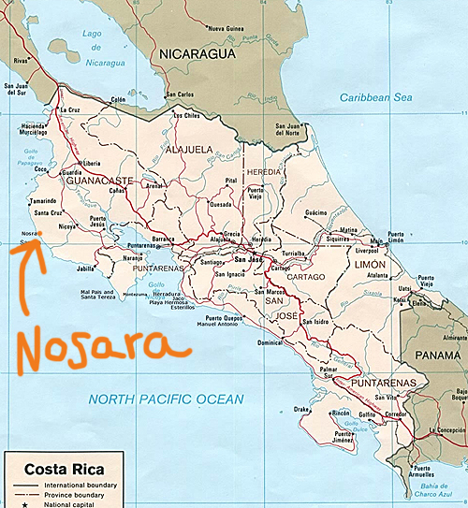

Day Two: 1. Breakfast 2. Early morning Surf Session with Safari Surf (SS) (All certified local guides, a highlight of the trip – SS also takes awesome pictures of the group) 3. Lunch 4. Lecture 5. Dinner 6. Welcome Bonfire

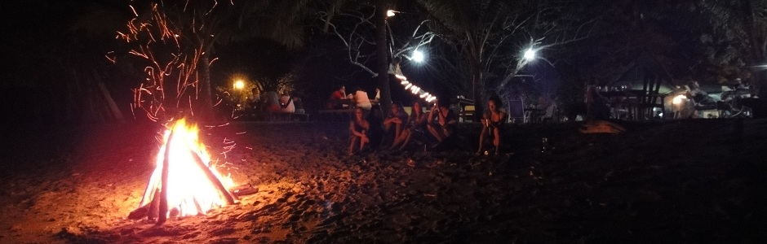

Day Three: 1. Early morning Surf Session optional lessons with Safari Surf 2. Breakfast 3. Lecture 4. Visit Surf Nosara Foundation (SNF) youth program – students volunteer by assisting with the education and recreation program. 5. Dinner

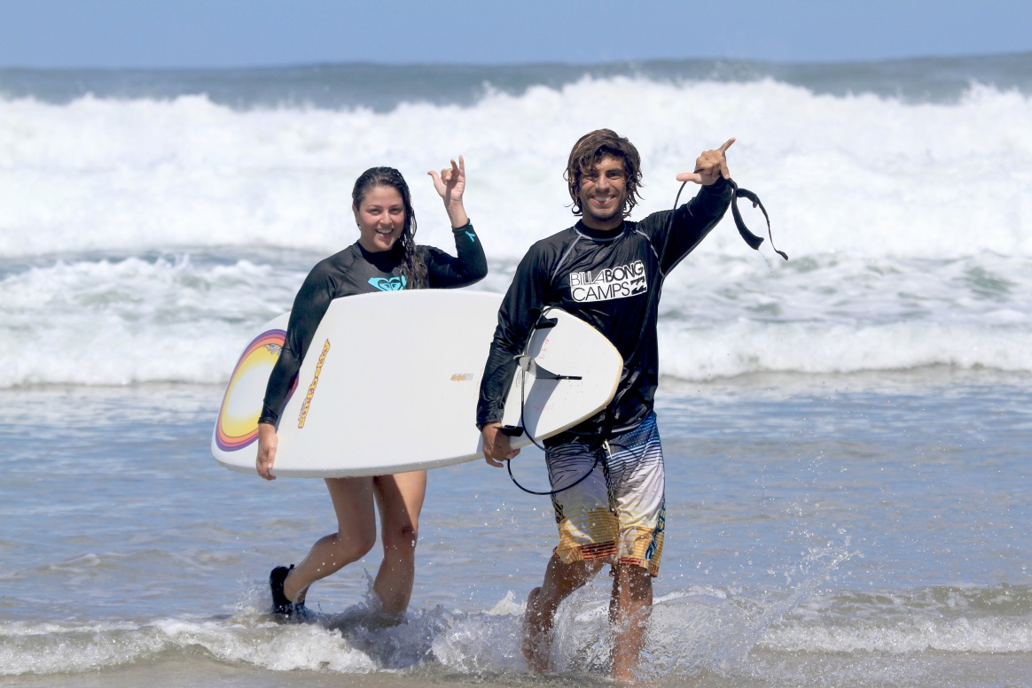

Day Four: 1. Early morning Surf Session 2. Breakfast 3. Lecture (Insert Topic) 4. Guided waterfall hike with local naturalist guide 5. Dinner 6. Movie night (Endless Summer II)

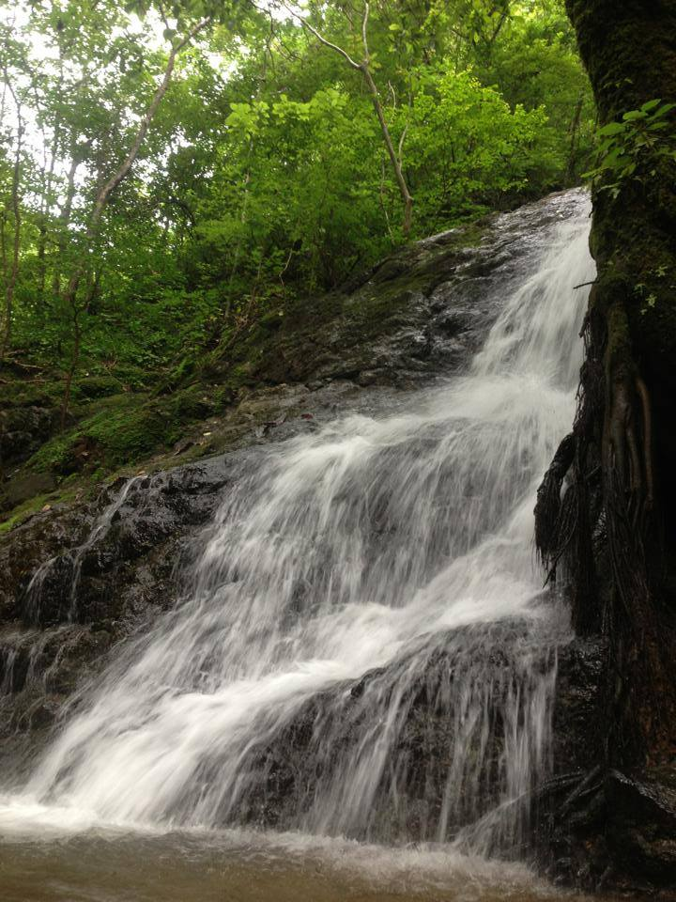
Day Five: 1. Early morning Surf Session 2. Breakfast 3. Lecture (Insert Topic) 4. Rio Nosara SUP tour – A student favorite: Introductory SUP lesson and discussion on the ecosystem, followed by an easy paddle through the mangroves, stop at secluded beach for a swim and a snack. 5. Exam 1

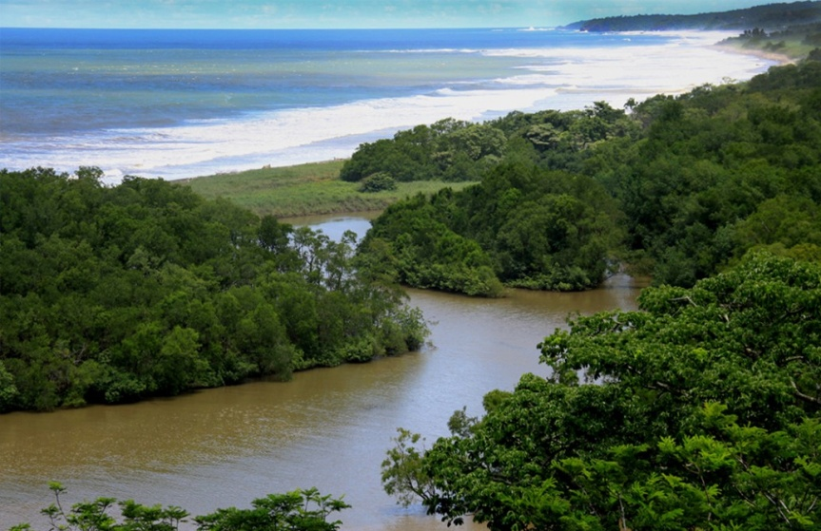

Dinner Day Six: 1. Early morning Surf Session 2. Breakfast 3. Lecture (Insert Topic) 4. Visit to Landfill and recycling center with guest lecture from Alvaro, the local in charge of administering the recycling project and other environmental advocacy in the area. 5. Dinner 6. Movie night

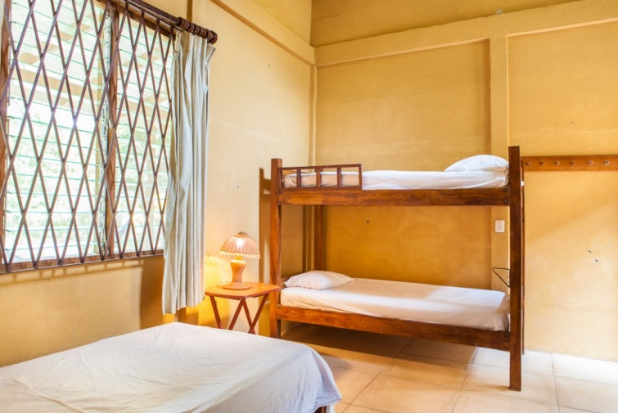

Day Seven: 1. Breakfast 2. Zipline Tour (not included $80 per student): This is very popular, but not included because fairly pricey and not all students typically want to do it. 3. Lunch 4. Visit the Harmony Hotel for a sustainability tour. 5. Evening surf 6. Dinner 7. Evening lecture

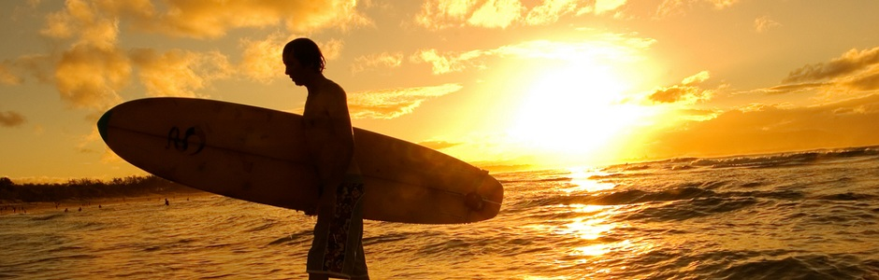

Day Eight: 1. Breakfast 2. Visit Barriguiones Reforestation Project. Guest talk from Gerardo, Local Forestry Engineer, about ecosystem services and importance of replanting native species on the coast. 3. Lunch 4. Fee Afternoon 5. Evening surf 6. Dinner 7. Evening lecture

Day Nine: 1. Morning Surf 2. Breakfast 3. Lunch 4. Free Afternoon 6. Dinner 7. Evening lecture

Day Ten: 1. Light Breakfast 2. Picked up in Vans 3. Visit Ostional Turtle Reserve Learn about the really unique• community driven program for turtle preservation and local use of turtle resources 4. Lunch in Ostional 5. Transfer to Playa Negra 6. Sunset Surf and BBQ 7. Transfer To Cabinas Las Olas In Avellanas

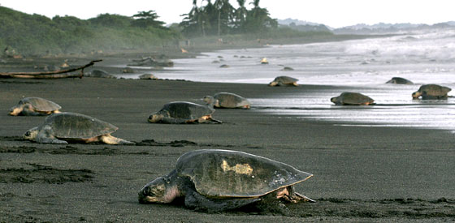

Day Eleven: 1. Breakfast 2. Avellanas Orientation 3. Mangrove hike to the beach 4. Optional Surf Session 5. Lunch 6. Talk about the local area and culture from local hotel operators 7. Dinner 8. Evening Lecture

Day twelve: 1. Breakfast 2. Free day to explore Avellanas 3. Optional Activity day: Boat Trip to Witches Rock, Horseback riding, Visit Playa Grande 4. Dinner 5. Bonfire

Day Thirteen: 1. Breakfast 2. Depart for day visit to Tamarindo, a very developed coastal city – issues include gentrification and pollution. 3. Lunch in Tamarindo 4. Transfer back to Cabinas Las Olas 5. Dinner 6. Movie

Day Fourteen: 1. Morning Surf 2. Breakfast 3. Transfer from Avellanas to Liberia Airport. 4.

Wed. Jan 20th: Return to Salisbury University. A bus will pick the class up at BWI and transport us back to the Salisbury University campus.
Thurs. Jan 21st: Students will spend the day completing their final projects.
Fri. Jan 22nd: Meet at Salisbury University, Henson Room 159, 9:00AM-12:00PM; Exam #2, Final projects due.

Final Project: Your final project will be to submit a trip journal or scrapbook. What I don’t want is your field book. I want you to take your notes and photos and other memorabilia to create some kind of day-by-day summary of the trip (not counting the two travel days). Each day you should talk about:
1. Where did we go?
2. What did we do?
3. What was the significance of the stop? (That is, what concept about the geography of surfing and/or Costa Rica was displayed at that stop?)
4. Maps and photos will help you earn a better grade than if you just give me a written description of the trip.

Other Important Information:
Flights : We are flying with U.S. Airways out of BWI. The flights are as follows:
Leave - The bus will leave Salisbury University at 5 am on Saturday, Jan. 8th (the pick-up site has not been determined yet). You can leave you cars in the lot all week since it is not during the regular semester. Our flight leaves Philadelphia at 9:40 am and lands in San Juan at 2:32 pm (they are actually a time zone ahead of us).
Return – Our flight leaves San Juan on Saturday Jan. 15th at 1:40 pm and we will land in Philadelphia at 4:40 pm. We should be back to Salisbury by 8 pm at the latest.
Baggage : The trip budget includes the $50 round trip bag charges. If your bag weighs more than 50 lbs. you will pay the extra bag fees. Overweight bag fees cost $70 for the round trip. If you bring your own surfboard(s), you are responsible for all associated costs.
Rooms : Students will be sharing rooms with two double beds during the trip. Two rooms are for the men and two rooms are for the women. Members of the opposite sex may not share a room!
Packlist for Costa Rica
Costa Rica is definitely a tropical locale with highs in the 80s and lows in the 70s. There is always a chance of rain but by and large January is not the rainy season. So you don’t need to pack heavy clothing.
In addition, we have to be able to get 15 people and their gear into 2 vans. Packing to a minimum is a must then. Each person is strictly limited to 1 large duffel bag/suitcase and a book bag or some other type of day pack.
We are going for 14 days and nights. Two of those days are travel days, so you can wear comfortable traveling clothes and slip-on-shoes or sandals are a good idea since airport security requires most people to take off their shoes before going through the metal detector. Make sure you do not have any knives, files, nail clippers, scissors or any other object which might be construed as a weapon on your person or in your carry-on. Airport security will confiscate it and then give you the full security search. In addition, you should not carry any bottles of liquid in your carry-ons. If you have to, it must be a small amount and the bottle(s) should be in a zip-lock bag.
You also must have passport with you at the time of check-in. Do not lock your bags, they will ask you to remove the locks at the ticket counter. There is also a weight limit for your bags (50 lbs.), try to pack light items as best you can. You are responsible for your own ticket!!!
Most of your fees (flight, rooms, vans and gas, boards) are paid for on the trip. Costa Rica uses the colon; you can exchange American money in the airport if you prefer, but most businesses accept U.S. dollars. You will need to bring money for food beyond what is provided, and for souvenirs. Local food stands are really good and cheap too. When we are staying in Nosara, we will get free breakfast, lunch, and dinner at the hostel.
The flight is not too long, but we’ll be hanging out in the airport waiting for flights, so bringing a book, a deck of cards, or some other activity is probably not a bad idea. Don’t plan on a good in-flight meal either.

Packlist :
- Clothes (summer)
- Travel clothes and shoes
- Sturdy hiking boots or shoes
- Windbreaker/raincoat (you never know)
- Sun hat
- Sunscreen
- Sunglasses
- Toiletries
- Money
- Passport and Health insurance card
- Camera (optional) – a disposable waterproof camera for snorkeling is a good thing too

