Study French in Quebec

Term To Study: | Summer 2015
Application Deadline: | January 26, 2015
Program Starts: | July 6, 2015
Program Ends: | July 24, 2015
Major 1: | n/a
Major 2: | n/a
Program Category: | Single-country
Program Type: | Faculty-led
Program Fee: | $2575
Program Countries: | Program Locations:
Canada | Jonquière, Québec
Contact Phone: | 304-876-5260
Contact Name: | Dr. Rachel Krantz
Contact Email: | rritterb@shepherd.edu
What is Included: | - Roundtrip transportation by car  - Travel insurance  - Lodging with a host family  - All meals  - Three weeks of language instruction by native French speakers from Quebec  - Many museum and attraction admissions
What is not Included: | - Tuition for FREN 411 Study Abroad (must be taken in conjunction with Quebec trip)  - Passport application or renewal fees  - Personal spending money  - Tips  - Optional weekend excursions (e.g. kayaking, whale watching)
Estimated Costs: | $2575
Documents: | C:\Users\rritterb\Documents\400-level French\FREN 411 Study abroad\FREN 411 course guidelines summer 2014.doc

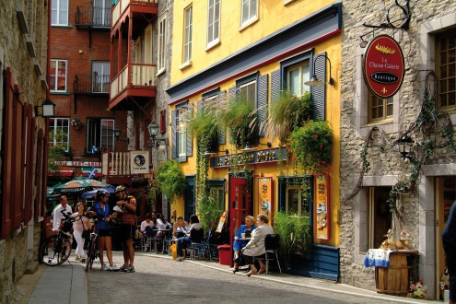
Program Description

Join the Shepherd Department of English and Modern Languages on an linguistic adventure in the heart of Quebec. Improve your French communication skills by living with a host family and taking courses at a local language school. At the same time, experience the unique mix of American and Continental traditions that makes Quebec so exciting.
Associated course: FREN 411 (Summer 2015)
Non-US passport holders should meet with the faculty leader to discuss potential visa issues PRIOR to enrolling in the program.

