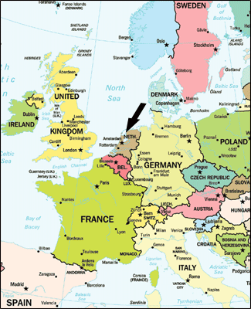

This study abroad trip includes a tour of several sites throughout the Netherlands, as well as the neighboring countries of Belgium, and Germany. With easy access to the United Kingdom and France, students will have the opportunity to experience the cultural diversity of Europe, while studying the cultural implications of the European Union on its members.

Instructors: Dr. Elizabeth Gagnon and Professor Sean Heuvel.

Study Abroad at Maastricht University

LDSP 330 Social Identity & Leadership in a Global Society

**Trip Dates:** June 14 – 29, 2015

**Cost:** $4500 – Includes airfare, lodging, and transportation to all sites included in the course curriculum.

**Information Sessions:**

9/2, 12:30 PM - DSU Washington Room

9/17, 4:00 PM - DSU Harrison Room

**Contact:** Dr. Elizabeth Gagnon, 594-8400

elizabeth.gagnon@cnu.edu