Biology 422
Tropical Ecology and Conservation

Costa Rica

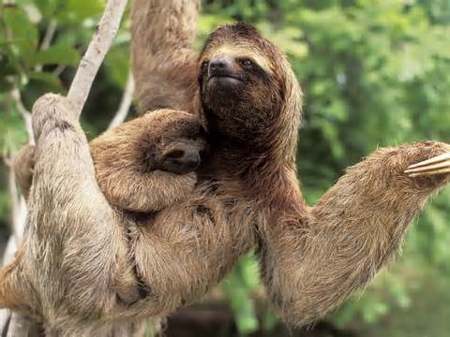 | 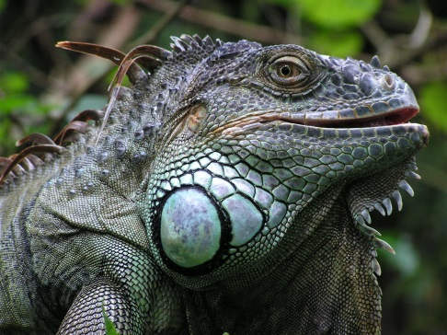 | 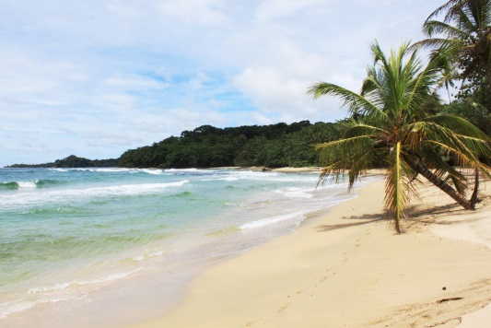

May 10 - May 24, 2015

Program Fee $3000.00 (may increase with later registration)
Program fee includes: Airfare, lodging, transportation, and meals.
Does not include: Tuition for 2 credit hours, personal expenses, or additional optional excursions.

Prerequisite: BIOL 430 Biogeography (offered spring semester 2015). Specific emphasis of this course will be on tropical biogeography, applied conservation of tropical ecosystems, and in developing student research projects which will be completed during our trip to Costa Rica.

Faculty Leaders:
Rick Sherwin: rsherwin@cnu.edu
Michael Meyer: Michael.meyer@cnu.edu

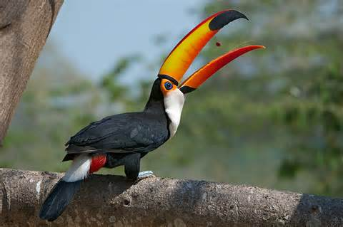 | 