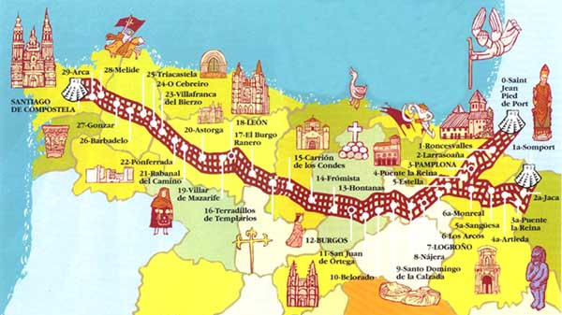
Camino de Santiago

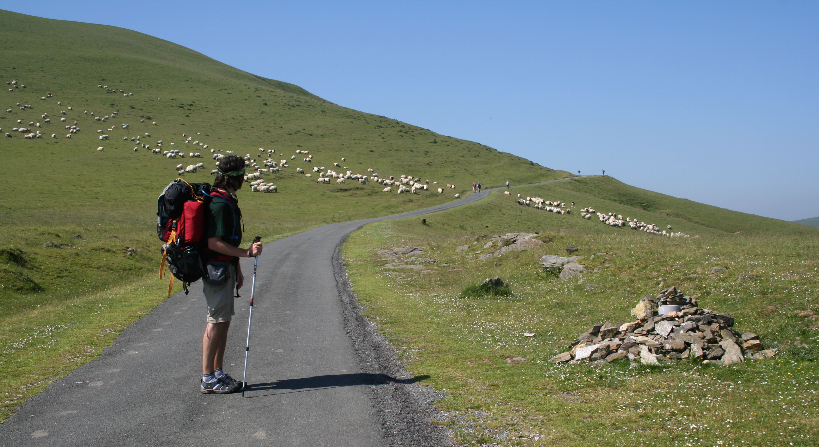
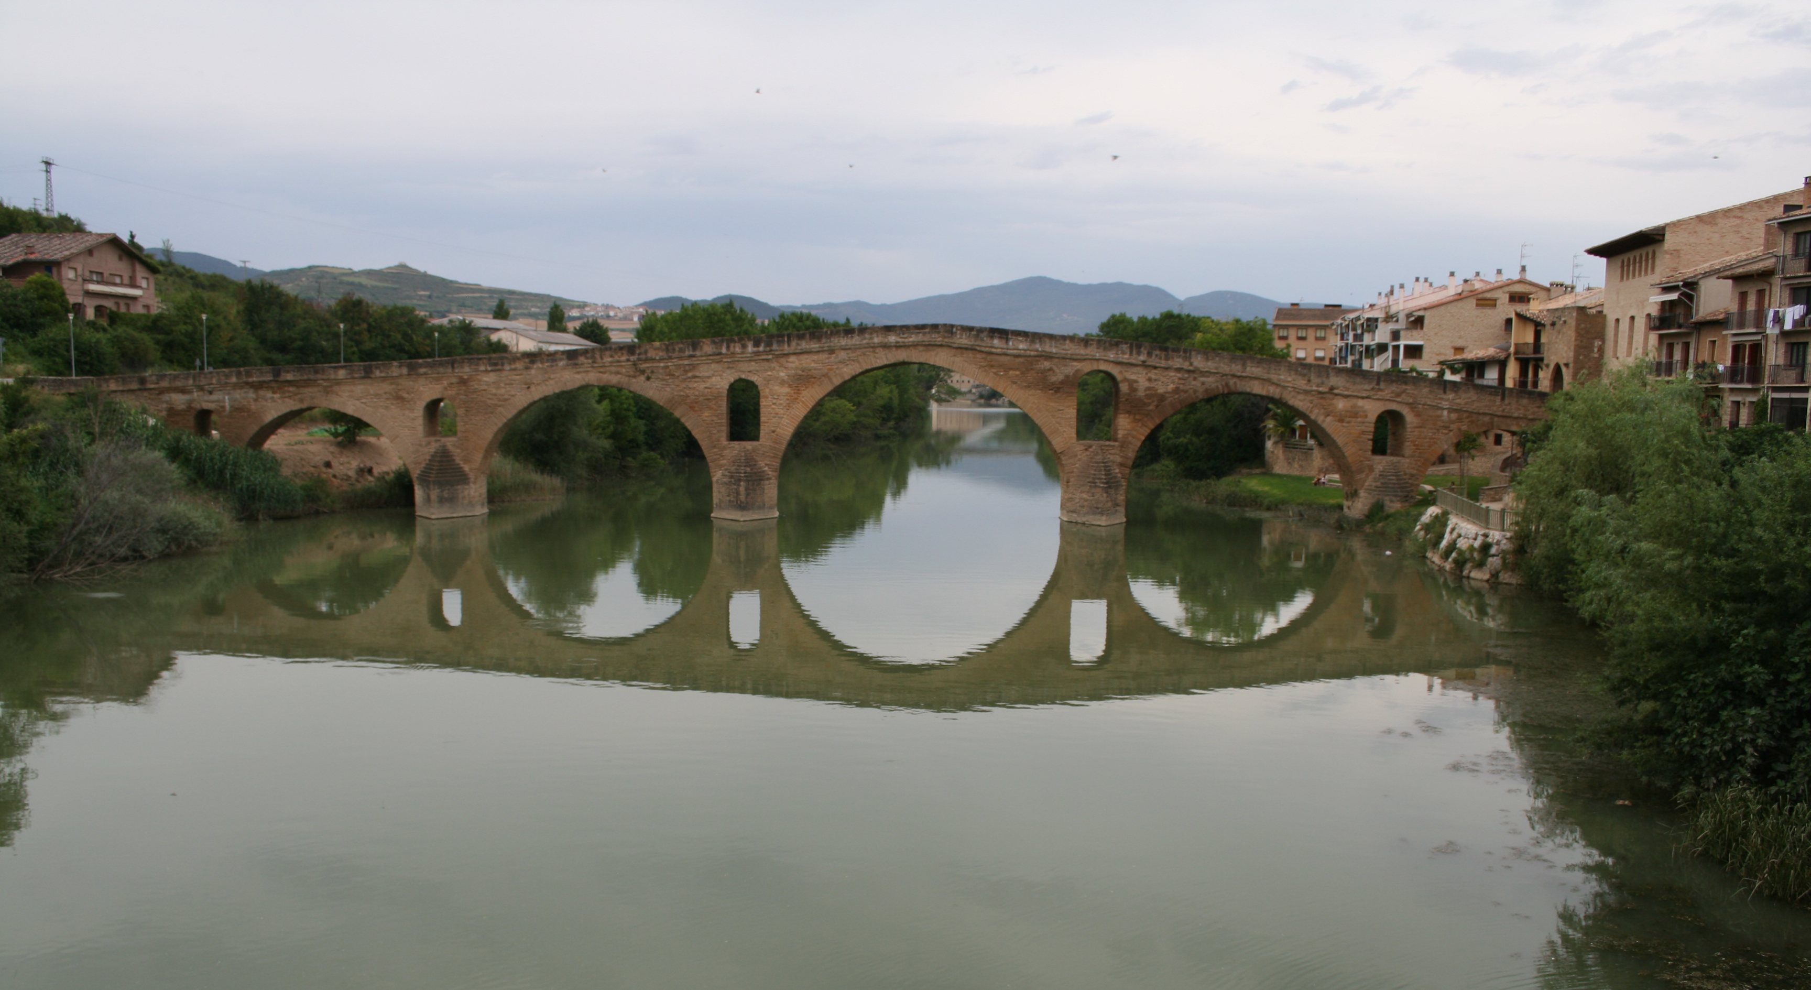

Over the Pyrenees
Across Architectural Wonders

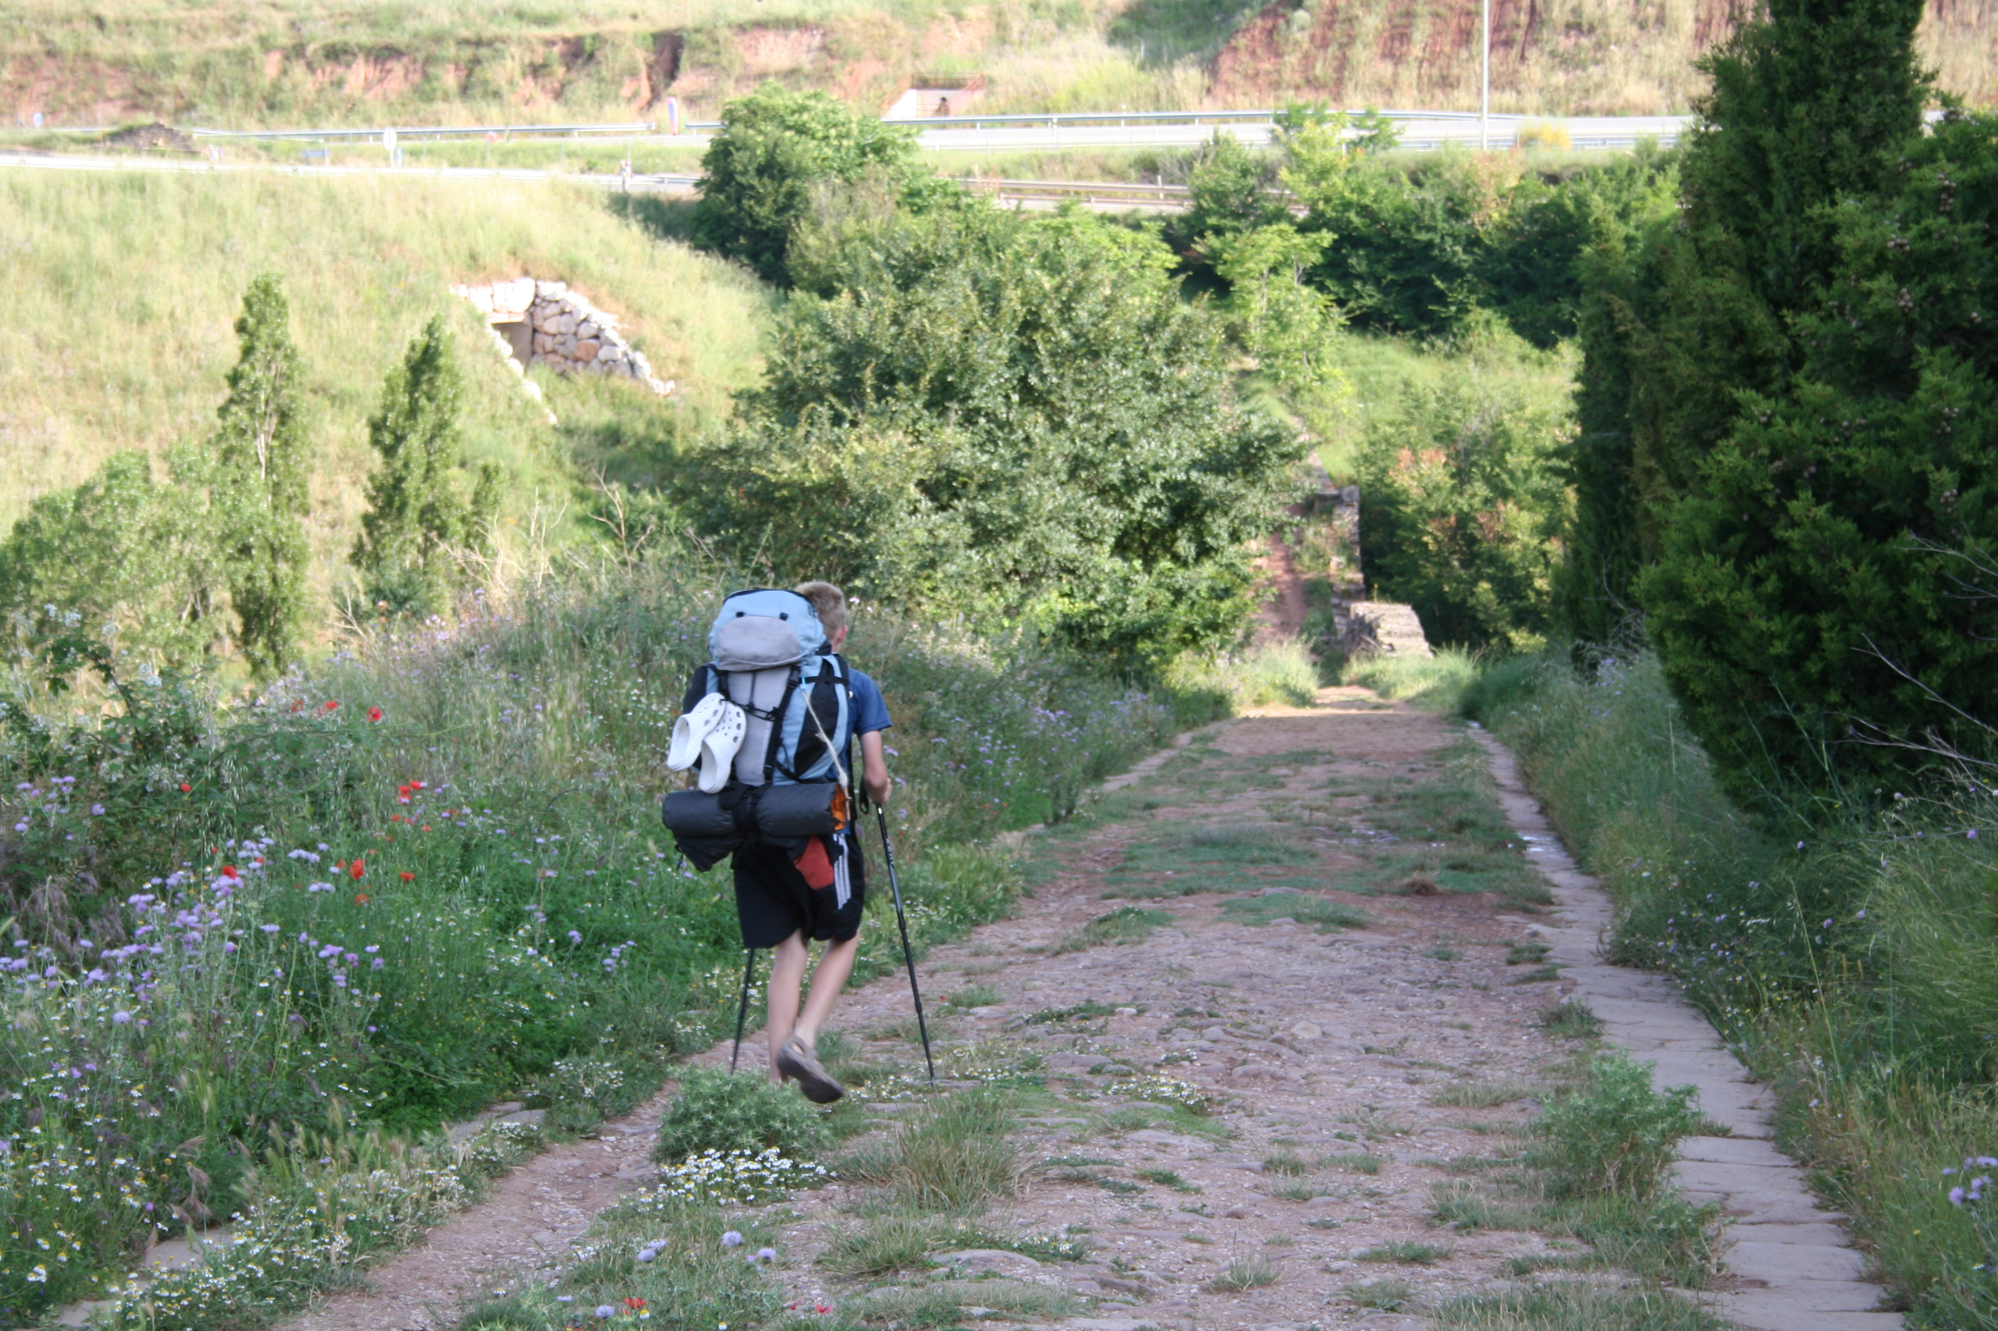
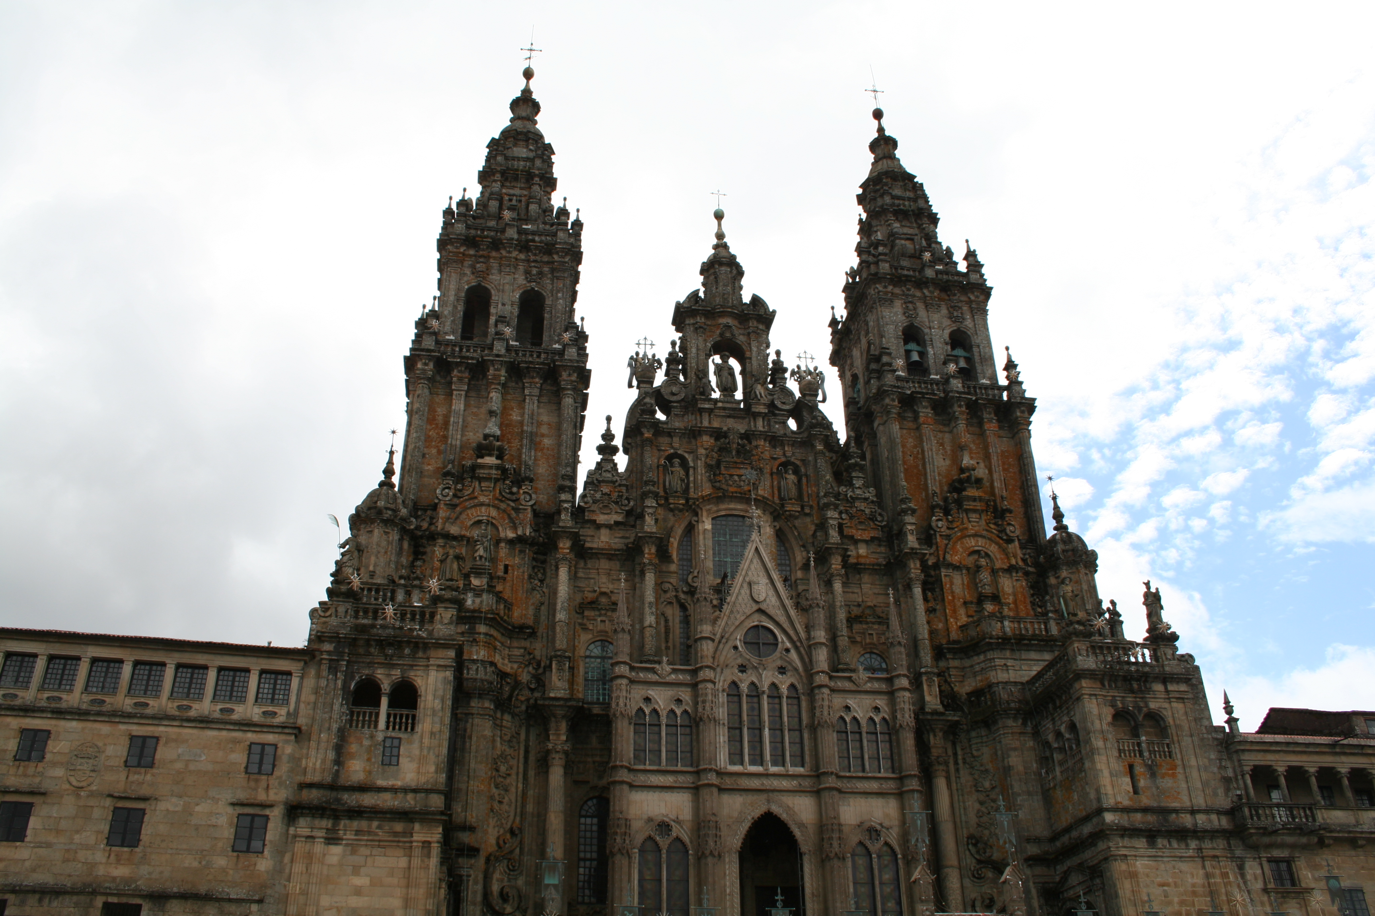

To the Cathedral of St. James
Along Roman Roads

Hike the Camino de Santiago with Dr. Kip Redick
A journey across Spain, A journey inward, A journey to remember
12 June to 28 July 2015
RSTD 370 for 3 Credits
For more information see
Dr. Redick McM 117 ph: 594-7801 kip.redick@cnu.edu
The Study Abroad Office in McMurran 104

